**Gold Standard for the Global Goals**

**Key Project Information & Project Design Document (PDD)**

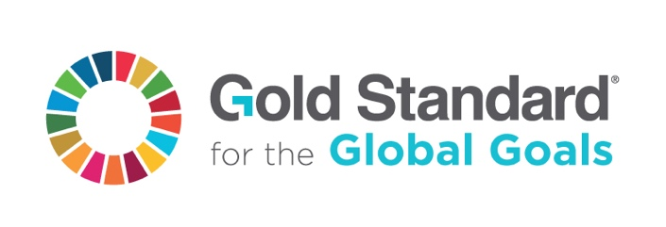

**Version 1.1 – June 2019**

**KEY PROJECT INFORMATION**

|  |  |
| --- | --- |
| Title of Project: | Gianyar Waste Recovery Project |
| Brief description of Project: | The project involves municipal solid waste MSW processing units in Temesi Village, Gianyar Region, Bali Province, Indonesia. A further objective is creating a large-scale model for waste processing in Indonesia. However, the facility with a capacity of 50 tons waste per day can process only a fraction of the waste created in the Gianyar region. The waste is processed through composting method and was implemented in the two phases:   1. 1st Phase: A 2340 m2 covered processing area with a capacity of maximum 30 tons waste per day- Commissioned on May 2008. 2. 2nd Phase: A 2400 m2 extension to 4740 m2 for a final capacity of up to 50 tons waste per day-Commissioned January 2010. |
| Expected Implementation Date: | The project has already been implemented at the below dates:   1. 1st Phase: A 2340 m2 covered processing area with a capacity of maximum 30 tons waste per day- Commissioned on May 2008. 2. 2nd Phase: A 2400 m2 extension to 4740 m2 for a final capacity of up to 50 tons waste per day-Commissioned January 2010. |
| Expected duration of Project: | 25 years |
| Project Developer: | Yayasan Pemilahan Sampah Temesi |
| Project Representative: | Mr. Sean Nino Lotze |
| Project Participants and any communities involved: | Yayasan Pemilahan Sampah Temesi  and  MyClimate – The Climate Protection Partnership |
| Version of PDD:  Date of Version: | 02  21/04/2020 |
| Host Country / Location: | Indonesia |
| Certification Pathway (Project Certification/Impact Statements & Products | Project Certification |
| Activity Requirements applied:  (mark GS4GG if none relevant) | GS4GG |
| Methodologies applied: | AMS-III.F.: Avoidance of methane emissions through composting, Version 12.0 |
| Product Requirements applied: | NA |
| Regular/Retroactive: | Retroactive |
| SDG Impacts: | 1. SDG 13: Climate Action 2. SDG 1 : No Poverty 3. SDG 3: Good Health and Well Being 4. SDG 6: Clean Water and Sanitation 5. SDG 11: Sustainable Cities and Communities |
| Estimated amount of SDG Impact Certified | SGD 13 -: 9,093tCO2e emission reduction per Annum  SGD 1 – 65 new jobs creation  SDG3 – 100% people confirm the improvement in their health condition in the monitoring sample survey  SDG6 – 100% people confirm the improvement in the clean water availability and sanitation facilities in the monitoring sample survey  SDG11: 17,500 tonne of waste processed in the plant per annum |

* 1. Description of project
     1. Purpose and general description of project

The project involves the implementation of a municipal solid waste processing unit in Temesi, Gianyar Region, Bali Province, Indonesia. A further objective is creating a large-scale model for waste processing in Indonesia. However, the facility with a capacity of 50 tons waste per day can process only a fraction of the waste created in the Gianyar region. The waste is processed through composting method and it is implemented in the two phases:

1. 1st Phase: A 2340 m2 covered processing area with a capacity of maximum 30 tons waste per day- Commissioned on May 2008.
2. 2nd Phase: A 2400 m2 extension to 4740 m2 for a final capacity of up to 50 tons waste per day-Commissioned January 2010.

As a first activity of composting, the waste separation is done by hand. The composting is equipped with air supply with the help of centrifugal blowers to assure the aerobic conditions. The waste is turned every two weeks to loosen the material and free air supply. After the initial de-composition, the raw compost is sieved to separate fine compost and coarse materials. The fine compost is further aerated to get the finished compost while the coarse material is sent back to the incoming organic waste for further decomposition. The project activity maintains the oxygen level of at around 12% in the waste which is more than required of 6% to assure aerobic composting.

In the baseline condition, the waste would have dumped in the landfill which results in anaerobic decomposition and emits methane to atmosphere. Since, the project is aerobic decomposition of waste through composting, it avoids the generation of methane. Hence, the project avoids GHG emission.

The project is a registered CDM project and it has completed the CDM crediting period. The details of the CDM registration are given below:

|  |  |
| --- | --- |
| CDM Project Title | Gianyar Waste Recovery Project |
| UNFCCC Reference no | 1885 |
| CDM Registration date | 04/11/2008 |
| Crediting period | 04/11/2008 – 03/11/2018 |
| CER issued until | 03/11/2018 |
| UNFCCC Link | <https://cdm.unfccc.int/Projects/DB/SGS-UKL1214472977.27/view> |

The proposed project activity also estimates to address the following sustainable parameters as mentioned in the UN Sustainable Development Goals (SDG)[[1]](#footnote-1).

|  |  |
| --- | --- |
| **SDG Goal** | **Relevant SDGs Targets** |
| 1. SDG 13: Climate Action | * Strengthen resilience and adaptive capacity to climate-related hazards and natural disasters in all countries * Integrate climate change measures into national policies, strategies and planning * Improve education, awareness-raising and human and institutional capacity on climate change mitigation, adaptation, impact reduction and early warning |
| 1. SDG 1 : No Poverty | * By 2030, eradicate extreme poverty for all people everywhere, currently measured as people living on less than $1.25 a day. * By 2030, reduce at least by half the proportion of men, women and children of all ages living in poverty in all its dimensions according to national definitions. |
| 1. SDG 3: Good Health and Well Being | By 2030, substantially reduce the number of deaths and illnesses from hazardous chemicals and air, water and soil pollution and contamination |
| 1. SDG 6: Clean Water and Sanitation | * By 2030, improve water quality by reducing pollution, eliminating dumping and minimizing release of hazardous chemicals and materials, halving the proportion of untreated wastewater and substantially increasing recycling and safe reuse globally |
| 1. SDG 11: Sustainable Cities and Communities | * By 2030, reduce the adverse per capita environmental impact of cities, including by paying special attention to air quality and municipal and other waste management |

The difference in Change in SD parameters are elaborated in the section B.6.5 of the PDD.

* + 1. Eligibility of the project under Gold Standard

|  |  |  |
| --- | --- | --- |
| **GS eligibility** |  | **Justification** |
| 3.1.1.1 A Project type is automatically eligible for Gold Standard Certification if there are Gold Standard published Activity Requirements and/or Gold Standard Approved Methodologies associated with it or as referenced in Gold Standard Product Requirements. These are published to the Gold Standard website and shall be followed where provided for a given Project type. | OK | As per Section 3 of ‘GS4GG Community Service Activity requirements’ v1.2, “All waste management activities that deliver energy OR a usable product with sustainable development benefits such as composting, biogas etc” are eligible under GS4GG.  Since, the project produce compost, a usable product with sustainable development benefits, the project activity is automatically eligible under the project type category “(c) Waste management and handling”, as defined in the GS Activity requirements[[2]](#footnote-2).  The CDM approved methodology AMS-III.F.: Avoidance of methane emissions through composting, Version 12.0, is applied to the project activity. |
| 3.1.1.2 For Project types not currently published to the Gold Standard website, the Project Developer may submit to Gold Standard for approval. This shall be done at minimum as part of the Preliminary Review, though it is recommended to engage with Gold Standard earlier to establish the criteria and requirements for approval. | *NA* | The project type is approved and published on the GS website. |
| 3.1.1.3 Project types applying for Gold Standard approval are referred to the Gold Standard Vision and Mission. The Project Developer shall demonstrate how the Project would contribute to these and how the Gold Standard for the Global Goals Requirements would be met in their application for approval. | *OK* | The project activity is implementation of municipal solid waste composting facility in Indonesia.  The project avoids CH4 emissions that would have occurred in the absence of the project at the conventional landfills without any CH4 recovery. Hence the project avoids the GHG emission that is responsible for climate change.  The monitoring process required to achieve the Global Goals, are also explained in the project document.  Therefore, the project activity is in line with the GS vision of “Climate security and sustainable development for all” and GS mission, “To catalyse more ambitious climate action to achieve the Global Goals through robust standards and verified impacts”. |
| 3.1.1.4 In reviewing a new Project type for approval, Gold Standard may establish new Requirements to be met by the Project in order to achieve Gold Standard Design Certification and ongoing Project Certification. Where required, Gold Standard shall engage expert peer reviewers to establish these Requirements, at the Project Developer's expense. | *NA* | *Non-Applicable* |
| 3.1.1.5 Gold Standard does not support Project types associated with geo-engineering or energy generated from fossil fuel or nuclear, fossil fuel switch, or any project that supports, enhances or prolongs such energy generation. In certain cases, concerning energy efficiency involving fossil fuels (for example, LPG stoves), an exception is made. This is captured in the relevant Activity Requirements, Gold Standard Approved Methodologies and/or Product Requirements. | *NA* | *Non-Applicable* |

* + 1. Legal ownership of products generated by the project and legal rights to alter use of resources required to service the project

The PP, Yayasan Pemilahan Sampah Temesi is the sole owner of the project activity. Hence, the GS VER’s generated from the project activity will be owned by the project owner ie, Yayasan Pemilahan Sampah Temesi.

* + 1. Location of project
       1. Host Country

Indonesia

* + - 1. Region/State/Province etc.

Region of Gianyar / Province of Bali

* + - 1. City/Town/Community etc.

Town of Temesi

* + - 1. Physical/Geographical location

The town of Temesi is situated two kilometres east of Gianyar, the capital of the Regency with the same name. The project is located at 115º 20' 59” east of Greenwich and 8º 33' 58” south of the equator. The location of the composting facility is depicted in below figure. The location is right next to the regencies open landfill.

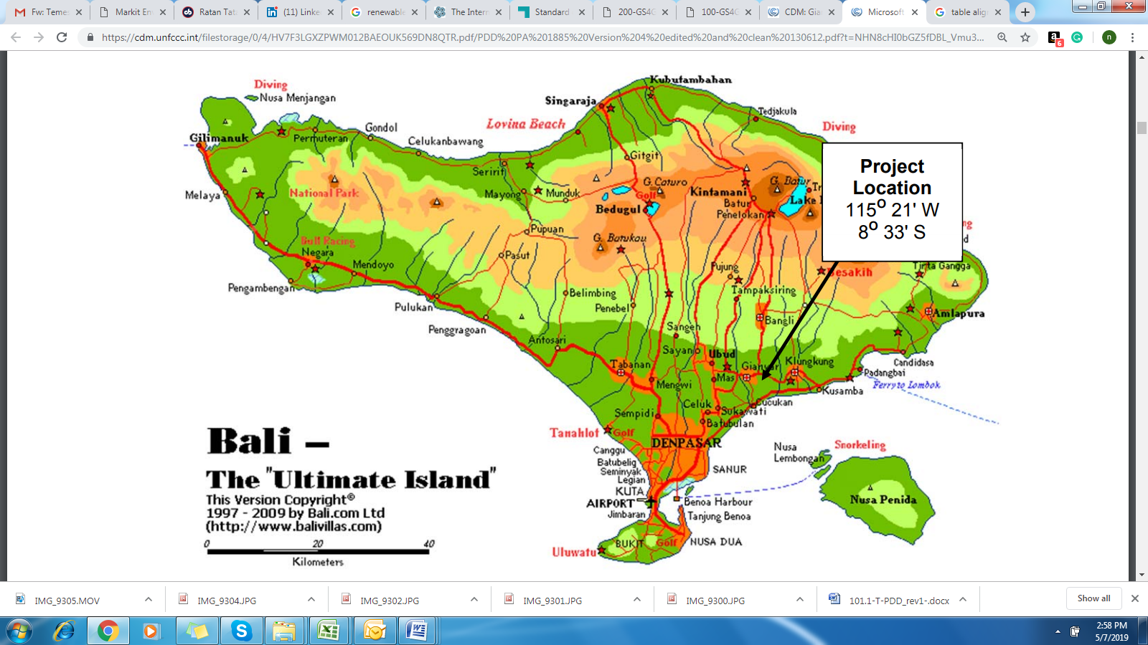

Figure 1: Project location map

* + 1. Technologies and/or measures

The technology used and measures applied in this project activity is to avoid the production of methane from the biomass fraction of municipal waste that would have otherwise been left for anaerobic decay in a solid waste disposal site without methane capture and flaring or power production. The decay is prevented through aerobic treatment by composting the organic waste fraction and proper soil application of the compost. The proper composting process is secured by adequate compost handling procedures and measures, including active aeration.

The project consists of the following equipment/installations:

* Electric compost sieves
* Composting surface (3,200 m2 ) and forced aeration system
* Covered light structures for waste processing, composting & compost storage (4,740 m2)
* Front loader and/or excavator for piling, turning and loading compost on site
* Transport vehicles for transporting organics & compost inside the facility as needed
* Compost turner
* Forced aeration system
* Weighbridge and/or weighing scales

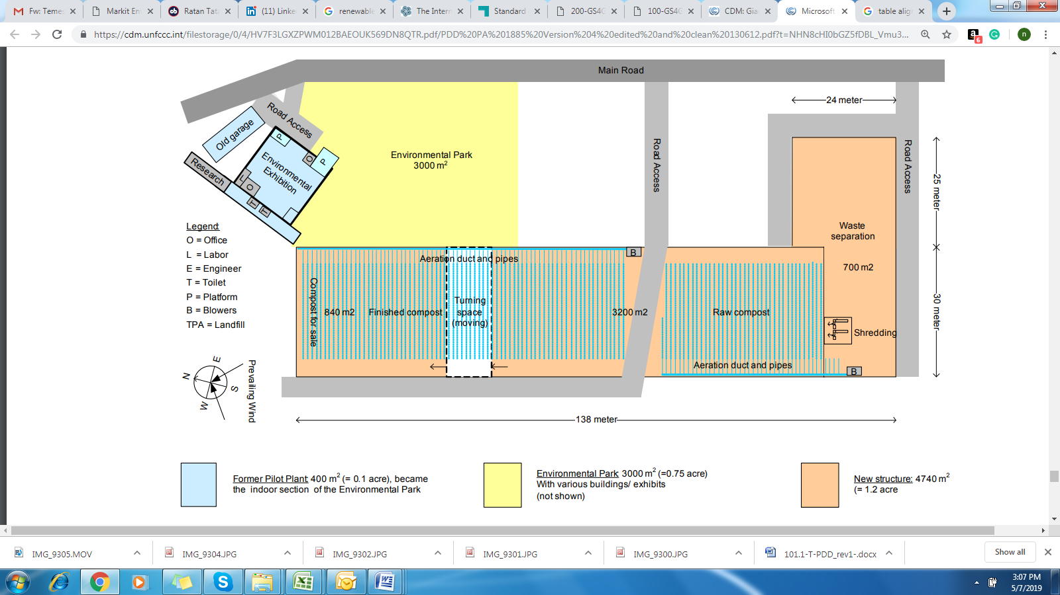

Figure 2: Layout of the Temesi Capacity Expansion from 5 to 50 tons per day

Positive contribution of the proposed project technology to at least three SDGs.

* + SDG 13: Climate Action:

The project reduces GHG emissions (CH4) by composting municipal solid waste, which otherwise would have been left for anaerobic decay in a solid waste disposal site without methane capture and flaring or power production

* SDG 1 : No Poverty

During construction of the projects many temporary jobs were given, mostly to the local people. Through the operation of this project, about 65 new jobs have been created and especially women are given jobs to run the plant. Hence, the project will help in alleviating the poverty in this region.

* SDG 3: Good Health and Well Being

Solid waste disposed in landfills without treating is generally hazardous as it contains toxic materials and a variety of pathogenic microorganisms[[3]](#footnote-3). These pathogens can create health problems to the communities who come under the influence of the landfills. Project provides showcase and education for organic waste management and plastics, papers, metals, glass management. Pathogenic microorganisms are eliminated by composting temperature exceeding 70 centigrade, thereby reducing the health hazards related to landfills. Hence, health hazards reduced in and around the landfill area especially in Temesi village due to the project. The project’s Quality System has operating procedures that assure worker’s safety (Procedure no. 24) and health (no. 25). It also provides a system for reporting inadequate conditions (no. 27) and for quality alerts (no. 28 that includes health and safety).

* SDG 6: Clean Water and Sanitation

The adjacent government landfill collects effluent and cleans it in a dedicated waste water treatment plant. No recyclable residue from the Temesi project is deposited on the landfill and potential toxics are treated along with the landfill effluent. In project scenario, organic wastes are composted and treated to remove toxic elements on the waste. Composting temperatures over 70 centigrade eliminate pathogens in the composting effluent thus making it harmless. By converting solid waste into compost and treating waste water to remove toxic elements will reduce the risk of the nearby water bodies getting polluted.

* SDG 11 :Sustainable Cities and Communities

In the pre-project scenario, treating waste produced from Gianyar Regency, Bali was a hectic task for the municipality. The landfills are not equipped properly to treat the organic wastes in the solid wastes. Solid wastes are dumped in the landfills without methane capturing and flaring nearby the village of Temesi. In the project scenario, the wastes are treated and converted in to compost which ease the task of waste management of the municipality. Furthermore, the project is a strong advocate for scaling and building decentralized and community owned material management facilities and effectively being a spokesperson on how to reduce waste to landfill and help measure and monitor future progress.

* + 1. Scale of the project

Micro Scale Project

(The annual estimated emission reduction of the project activity is 9,093 tCO2e which is within the micro scale limit of 10,000 tCO2eq/yr as per section 3.1.2 of GS4GG Community Services Activity Requirements v1.2)

* + 1. Funding sources of project

The Rotary Club Bali Ubud has implemented the project with the help of public funding, but the fund does not result in a diversion of Official Development Assistance (ODA). Now the complete ownership of the project lies with ‘Yayasan Pemilahan Sampah Temesi’ who is the project participant in this project.

* + 1. Assessment that project complies with ‘gender sensitive’ requirements

The project activity does not seek the gender certification at the performance level, therefore does not include the second level (gender-responsive). The section below provides the project assessment to demonstrate that the project activity complies with the ‘gender sensitive’ section according to the ‘GS Gender equality guidelines and requirements’ -

**STEP 1: BASIC CONTEXT**

1. Does the project reflect the key issues and requirements of Gender Sensitive design and implementation as outlined in the Gender Policy? Explain how

The project is not a new project. Hence, it is not applicable at this stage.

2. Does the project align with existing country policies, strategies and best practices? Explain how.

In Indonesia, the policy on gender equality and empowerment of women has been adopted at the international and national levels[[4]](#footnote-4):

* + 1. at the international and national levels, through the ratification of the UN Convention on the Elimination of All Forms of Discrimination against Women with Law Number 7/1984;
    2. at the national level, through the People’s Consultative Assembly (the highest political body in Indonesia) Decree Number IV/MPR/1999 on the Broad Guidelines of State Policy 1999-2004;
    3. the establishment of National Machinery for the Advancement of Women with the Presidential Decree of 1978;
    4. Law Number 25/2000 on the National Development Programme;
    5. Presidential Instruction Number 9/2000 on Gender Mainstreaming in National Development;
    6. National Action Plan for the Elimination of Violence Against Women;
    7. the inclusion of gender-mainstreaming policy in 38 programmes of the National Development Programme (2000-2004);
    8. Law Number 23/2002 on Child Protection;
    9. Presidential Decree Number 87/2002 on National Plan of Action on Eradication of Child Commercial Sexual Exploitation;
    10. Presidential Decree Number 88/2002 on National Plan of Action on Elimination of Trafficking in Women and Children;
    11. Law no. 12/2003 on General Election in which each political party participating in a general election should consider at least 30% of women representation in the nomination of its members of national, provincial and local representative council.

Indonesia is ranked 115 out of 188 countries in 2016 on its Gender Inequality Index (GII)[[5]](#footnote-5). The project implemented in Indonesia complies with all the laws and policies of the gender equality as follows.

* + *The project activity promotes and encourages active participation of women and men during the stakeholder meetings, giving an equal opportunity to both genders.*
  + *The project provides equal employment opportunities for men and women. The project created 65 new jobs and especially women are given jobs to run the plant.*
  + *Equal pay for equal work is followed. No discrimination is made in the salaries of men and women.*
  + *The science lab, administration and finance are all managed by women.*

Hence, the project aligned with existing country policies, strategies and best practices**.**

**STEP 2: APPLY GOLD STANDARD SAFEGUARDING PRINCIPLES**

3. Does the project address the questions raised in the Gold Standard Safeguarding Principles & Requirements document? Explain how.

The project addressed all the questions raised in the Gold Standard Safeguarding Principles & Requirements document. Please refer section D of this report for detailed assessment on the project’s compliance with Gold Standard Safeguarding Principles & Requirements.

**STEP 3: CONDUCT STAKEHOLDER CONSULTATION**

4. Does the project apply the Gold Standard Stakeholder Consultation & Engagement Procedure, Requirements & Guidelines? Explain how.

The project applied the Gold Standard Stakeholder Consultation & Engagement Procedure, Requirements & Guidelines. Please refer Section E for detailed explanation.

* 1. Application of selected approved Gold Standard methodology
     1. Reference of approved methodology

The project activity applied latest CDM methodology AMS-III.F.: Avoidance of methane emissions through composting, Version 12.0[[6]](#footnote-6).

The methodology also refers the below tool:

* Tool to calculate project or leakage CO2 emissions from fossil fuel combustion, version 3
* Emissions from solid waste disposal sites, version 8
* Baseline, project and/or leakage emissions from electricity consumption and monitoring of electricity generation , version 3
* Project and leakage emissions from composting, version 2
  + 1. Applicability of methodology

|  |  |
| --- | --- |
| **Applicability** | **Justification** |
| **Scope** |  |
| This methodology comprises measures to avoid the emissions of methane to the atmosphere from biomass or other organic matter that would have otherwise been left to decay anaerobically in a solid waste disposal site (SWDS), or in an animal waste management system (AWMS), or in a wastewater treatment system (WWTS). In the project activity, controlled aerobic treatment by composting of biomass is introduced | The project involves reduction of methane emission to atmosphere from organic matter (of municipal solid waste) that would have otherwise been left to decay anaerobically in a solid waste disposal site (SWDS). In the project activity, controlled aerobic treatment by composting of biomass is introduced.  Hence, the project fulfils the applicability conditions |
| The project activity does not recover or combust landfill gas from the disposal site (unlike AMS-III.G “Landfill methane recovery”), and does not undertake controlled combustion of the waste that is not treated biologically in a first step (unlike AMS-III.E “Avoidance of methane production from decay of biomass through controlled combustion, gasification or mechanical/thermal treatment”). Project activities that recover biogas from wastewater treatment shall use the methodology AMS-III.H “Methane recovery in wastewater treatment”. Project activities involving co-digestion of organic matters shall apply the methodology AMS-III.AO “Methane recovery through controlled anaerobic digestion”. | The project activity is involves composting of organic fraction of municipal solid waste. It does NOT involves any of the below:   * Recover or combust landfill gas from disposal site * Undertake controlled combustion of the waste that is not treated biologically in a first step * Recover biogas from wastewater treatment * Co-digestion of organic matters   Hence, the project fulfils the applicability conditions. |
| Measures are limited to those that result in emission reductions of less than or equal to 60 kt CO2 equivalent annually. | The annual average emission reduction from the project is 9,093 tCO2e/year (ie, 9.093 k tCO2e/year) which is less than 60 kt CO2 equivalent annually.  Hence, the project fulfils the applicability conditions |
| This methodology is applicable to the composting of the organic fraction of municipal solid waste and biomass waste from agricultural or agro-industrial activities including manure. | The project activity involves installation of composting facility which process organic fraction of municipal solid waste into compost. Hence, the project satisfies the applicability condition. |
| This methodology includes construction and expansion of treatment facilities as well as activities that increase capacity utilization at an existing facility. For project activities that increase capacity utilization at existing facilities, project participant(s) shall demonstrate that special efforts are made to increase the capacity utilization, that the existing facility meets all applicable laws and regulations and that the existing facility is not included in a separate CDM project activity. The special efforts should be identified and described | The project activity is the expansion of the existing facility’s capacity from 4 tonne to 50 tons of waste per day or around 17'500 tons per year, to cope with a larger fraction of waste in the Gianyar Regency with its 500'000 inhabitants.  The existing facility was a pilot plant with just 4 tonnes/day processing capacity. The project plant capacity is 50 tonnes/day ie, more than 12 times higher than the existing capacity which was built in compliance with all applicable laws and regulation in the country.  The existing facility is not registered as separate CDM project. The same shall be checked from the UNFCCC website project search.  Hence, the project fulfils the applicability conditions. |
| This methodology is also applicable for co-composting wastewater and solid biomass waste, where wastewater would otherwise have been treated in an anaerobic wastewater treatment system without biogas recovery. The wastewater in the project scenario is used as a source of moisture and/or nutrients to the biological treatment process e.g. composting of empty fruit bunches (EFB), a residue from palm oil production, with the addition of palm oil mill effluent (POME) which is the wastewater co-produced from palm oil production. | The condition is not applicable for this project as the project does not involve co-composting. |
| In case of co-composting, if it cannot be demonstrated that the organic matter would otherwise been left to decay anaerobically, baseline emissions related to such organic matter shall be accounted for as zero, whereas project emissions shall be calculated according to the procedures presented in this methodology for all co-composted substrates. | Not applicable. |
| The location and characteristics of the disposal site of the biomass, animal manure and co-composting wastewater in the baseline condition shall be known, in such a way as to allow the estimation of its methane emissions, using the provisions of AMS-III.G, AMS III.E (concerning stockpile), AMS-III.D “Methane recovery in animal manure management systems” or AMS-III.H respectively. | The project involves composting of organic fraction of municipal solid waste which otherwise would have disposed at the land fill site.  The project does not involve composting of biomass, animal manure or co-composting. Hence, this condition not applicable for this project. |
| Blending materials may be added in the project scenario to increase the efficiency of the composting process (e.g. to achieve a desirable C/N ratio or free air space value), however, only monitored quantity of solid waste or manure or wastewater diverted from the baseline treatment system is used for emission reduction calculation. Project activities for composting of animal manure shall also meet the requirements under paragraphs 3 and 4(c) of the latest version of AMS-III.D. | Only the quantity of municipal solid waste that was diverted from the baseline disposal site ie, land fill is considered for emission reduction calculation. No emission reduction will be claimed for the blending materials.  Hence, the project fulfils the applicability condition. |
| For solid wastes diverted from a solid waste disposal site, the following requirement shall be checked ex ante at the beginning of each crediting period:  (a) Establish that identified landfill(s)/stockpile(s) can be expected to accommodate the waste to be used for the project activity for the duration of the crediting period; or  (b) Establish that it is common practice in the region to dispose of the waste in solid waste disposal site (landfill)/stockpile(s). | The capacity of existing landfill at Temesi is adequate to accommodate the waste for another 10 years at the baseline waste incoming quantity which is higher than the proposed GS crediting period of 5 years.  The landfilling and illegal dumping of waste is the most common waste management method in Bali Province[[7]](#footnote-7).  Hence, the project fulfils the applicability condition. |
| The project participants shall clearly define the geographical boundary of the region referred in paragraph 11(b), and document it in the CDM-PDD. In defining the geographical boundary of the region, project participants should take into account the source of the waste i.e. if waste is transported up to 50 km, the region may cover a radius of 50 km around the project activity. In addition, it should also consider the distance to which the final product after composting will be transported. In either case, the region should cover a reasonable radius around the project activity that can be justified with reference to the project circumstances but in no case it shall be more than 200 km. Once defined, the region should not be changed during the crediting period(s). | There is no difference in waste collection and transportation patterns due to the project activity compared to the baseline case, where the waste is just dumped on the landfill site, since landfill and composting facility are at the same location. Additionally, the total amount of waste collected remains the same, with or without the project activity. Hence, no additional waste transportation is required compare to baseline condition. However, the compost produced from the project will be sold to farmers that transported to the agricultural fields. Majority of the customers of located between project site and west of Denpasar which is 62 km far from site. Hence conservatively 62 km is considered in the project boundary.  Hence, the project fulfils the applicability condition |
| In case produced compost is handled aerobically and submitted to soil application, the proper conditions and procedures (not resulting in methane emissions) must be ensured. | Conditions and procedures are set for the compost handling to ensure no methane is emitted during the handling.  Hence, the project fulfils the applicability condition |
| In case produced compost is treated thermally/mechanically, the provisions in AMS-III.E related to thermal/mechanical treatment shall be applied. | No thermal or mechanical treatment is involved in the post production process.  Hence, the project fulfils the applicability condition |
| In case produced compost is stored under anaerobic conditions and/or delivered to a landfill, emissions from the residual organic content shall to be taken into account and calculated as per the latest version of the methodological tool “Emissions from solid waste disposal sites”. | The produced compost is sold to customers as and when it is produced. The compost is not stored under anaerobic condition or delivered to landfill. Hence the condition is not applicable for this project. |

The project satisfies all relevant applicability requirements of the applied methodology AMS-III.F.: Avoidance of methane emissions through composting, Version 12.0.

* + 1. Project boundary

As per the para 51 of the applied methodology, the project boundary is defined as the physical, geographical location of the following:

* 1. The landfill site, where the solid waste would have been disposed and the methane emission occurs in absence of the proposed project activity;
  2. The composting facility, where the treatment of biomass through composting takes place;
  3. Consumer places where the compost is handled, disposed, submitted to soil application.;
  4. And the itineraries between b and c where the transportation of compost occurs. It should be noted that the waste transportation itineraries between a & b are not considered as the project site is located next to the landfill site.

Project boundary

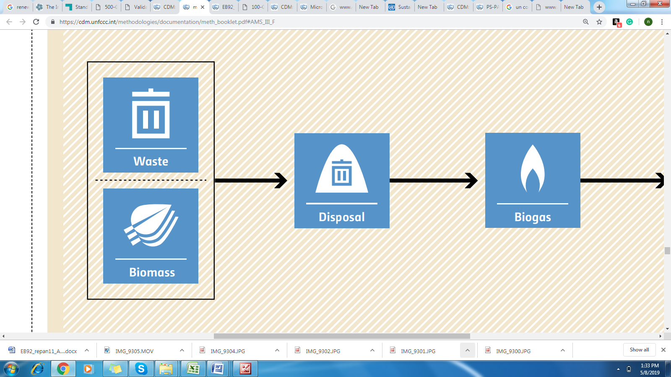

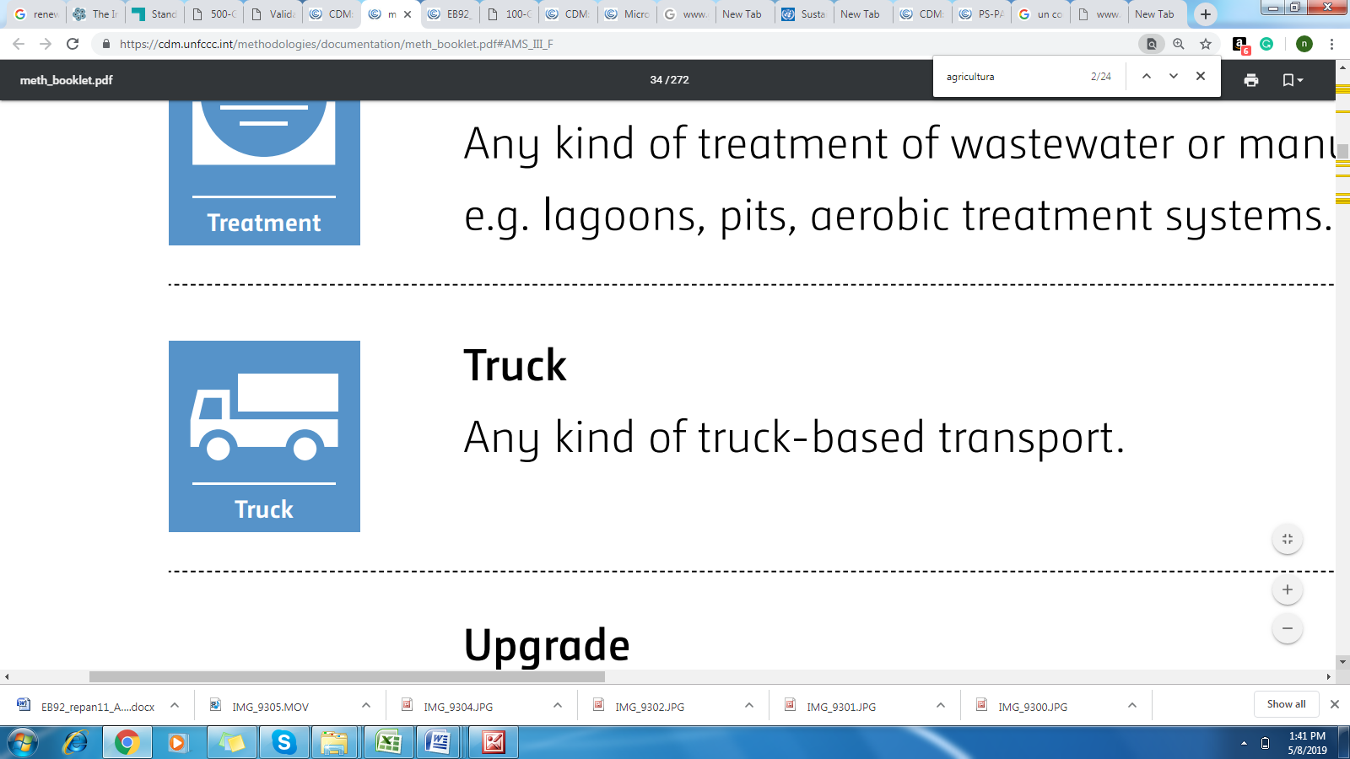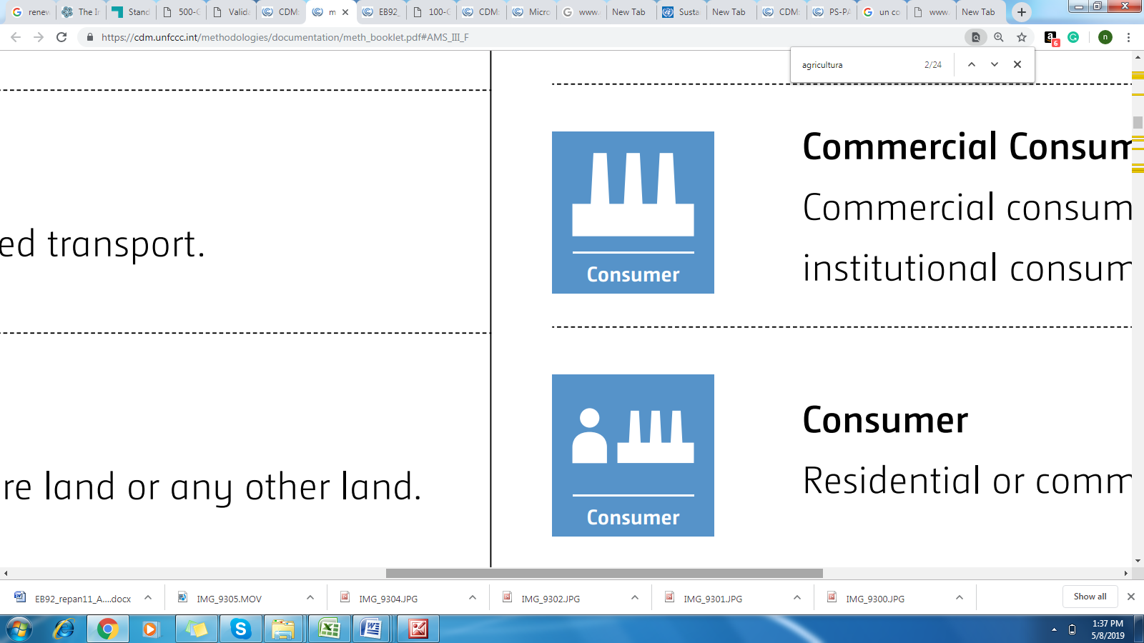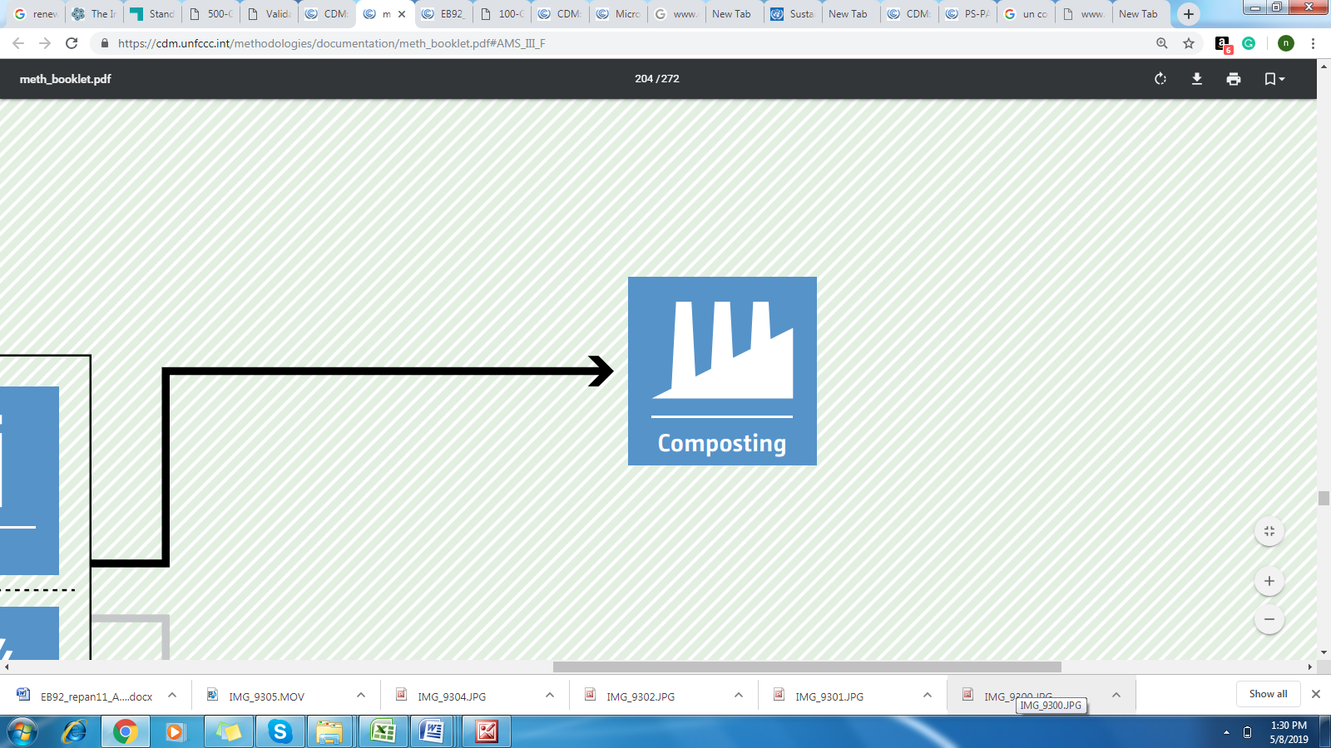

For the purpose of GHG mitigation/sequestration following table shall be completed (delete if not required)

|  |  |  |  |  |
| --- | --- | --- | --- | --- |
| **Source** | | **GHGs** | **Included?** | **Justification/Explanation** |
| **Baseline scenario** | Landfill site | CO2 | No | Not significant. |
| CH4 | Yes | Main source of emission |
| N2O | No | Not significant. |
| **Project scenario** | Composting site | CO2 | Yes | Emission from diesel consumption and electricity consumption at site |
| CH4 | Yes | Significant emission from composting |
| N2O | Yes | Significant emission from composting |

* + 1. Establishment and description of baseline scenario

In the absence of the project activity, organic matter in the municipal solid waste will be dumped and left to decay at the landfill site located within the project boundary and methane is emitted to the atmosphere. Hence the baseline scenario is the continued dumping of the waste on the existing landfill site in the absence of the project activity.

The baseline emissions are the amount of methane emitted from the decay of the degradable organic carbon in the biomass solid waste. The yearly Methane Generation Potential for the solid waste is calculated using the first order decay model as described in the latest version of the methodological tool “Emissions from solid waste disposal sites”. The formula and its parameters are explained in detail in section B.6.2 For most of the parameters the IPCC default values or recommendations given in the methodology have been followed, since no location or region-specific information is available. Where required and available project specific data and information from the plant operator is used.

* + 1. Demonstration of additionality

Additionality determination of the project activity follows roughly the “Demonstration of additionality of small-scale project activities, version 13”, with simplification for small-scale project activities as applicable.

**Barrier analysis**

In this step, it is determined whether the proposed project activity faces barriers that:

1. Prevent the implementation of this type of proposed project activity; and
2. Do not prevent the implementation of at least one of the alternatives.

As per small-scale requirement at least one significant barrier needs to be identified. However, the argumentation is based on two closely related barriers: financial barrier and market barrier.

A. Financial barriers:

Due to a number of reasons, it is very difficult to make any waste management projects of this scale commercially viable. Yet financial debility is almost a common syndrome for the local bodies, and the limited financial strength of a municipality is therefore one of the main barriers to such a project to be implemented and operated by the official regional authorities. The financial viability problems also prevented any private sector participation so far, unless non-profit organizations, as in this project, initiate innovative approaches by spending a lot of time and voluntary work.

The capital investment in the compost plant is primarily for the civil structures, mechanical equipment and vehicles. Despite the fact that composting technology is relatively simple and less expensive, in absolute terms the capital investment is still high and the financial prospects too low to attract any private investment. However, most of the necessary capital investment has been funded, donated respectively by private or public entities. The operation and maintenance cost are fairly high compared to the uncertain market price and demand of compost (end product). Therefore, additional support is necessary to make the urban waste-based compost plant viable and sustainable. In this context CDM revenues could make a very positive impact in making such projects viable and would also open up possibilities for private sector participation in the future.

Ongoing financial Need

To support the Ongoing Financial Need a monthly profit and loss statement is attached as Appendix 3.

B. Market barrier:

In Indonesia and Bali, the concept of soil conditioner is still not widely known amongst the farmers, the largest potential client/ user group of the composting facility, and compost from municipal waste is still considered as being "dirty". This coupled with the low levels of certain plant nutrients on a per ton basis in comparison to the chemical fertilizers leads to low market price of compost. Hence, the sale of compost produced from the municipal solid waste poses a challenge and the sale of all the compost still presents a major challenge in the project activity[[8]](#footnote-8). The additional costs for building the distribution network and the current lack of a sales network and experience pose other significant barriers for the market entry of the project organisation.

Potential revenues generated from trading in the Emission Reduction (ER) from this project would therefore assist in:

1. Making the product available at a competitive price,
2. Market development for compost.

All the above described barriers pose a serious obstacle to the project activity, and would lead to high operational uncertainties if not implemented as CDM project activity.

**Conclusion:**

Since the project faces above barriers, the project is clearly additional and would not be realised as proposed without the additional revenue from sale of carbon credits.

**Serious Consideration of Carbon revenue:**

The important timeline of the project activity are listed below:

|  |  |  |
| --- | --- | --- |
| **Activity** | **Date** | **Reference** |
| Webhosting of initial PDD for GSC under CDM | 27/07/2007 | CDM Validation Report, section 5.1 &  <https://webapps.sgs.com/quality-network/> |
| Construction Start date of the project activity | 18/08/2007 | Registered PDD, section C.1.1 |
| Re-webhosting of revised PDD for GSC | 11/04/2008 | CDM Validation Report, section 5.1 &  <https://webapps.sgs.com/quality-network/> |
| Re-webhosting of revised PDD for GSC | 28/03/2008 | CDM Validation Report, section 5.1 &  <https://webapps.sgs.com/quality-network/> |
| Commissioning of 1st Phase of the project | 01/05/ 2008 | Plant records |
| Registration of project activity | 04/11/2008 | UNFCCC Project page:  <https://cdm.unfccc.int/Projects/DB/SGS-UKL1214472977.27/view> |
| CDM Crediting period | 04/11/2008 – 03/11/2018 | <https://cdm.unfccc.int/Projects/DB/SGS-UKL1214472977.27/view> |
| GS Stakeholder consultation | 28/02/2019 | Section E below |

From the above project activities, it is evident that the project proponent has taken real action to secure carbon status for the project in parallel with implementation of the project activity

.

* + 1. Sustainable Development Goals (SDG) outcomes
       1. Relevant target for each of the five SDGs

|  |  |
| --- | --- |
| **SDG Goal** | **Relevant SDGs Targets** |
| 1. SDG 13: Climate Action | * Strengthen resilience and adaptive capacity to climate-related hazards and natural disasters in all countries * Integrate climate change measures into national policies, strategies and planning * Improve education, awareness-raising and human and institutional capacity on climate change mitigation, adaptation, impact reduction and early warning |
| 1. SDG 1 : No Poverty | * By 2030, eradicate extreme poverty for all people everywhere, currently measured as people living on less than $1.25 a day. * By 2030, reduce at least by half the proportion of men, women and children of all ages living in poverty in all its dimensions according to national definitions. |
| 1. SDG 3: Good Health and Well Being | By 2030, substantially reduce the number of deaths and illnesses from hazardous chemicals and air, water and soil pollution and contamination |
| 1. SDG 6: Clean Water and Sanitation | * By 2030, improve water quality by reducing pollution, eliminating dumping and minimizing release of hazardous chemicals and materials, halving the proportion of untreated wastewater and substantially increasing recycling and safe reuse globally |
| 1. SDG 11: Sustainable Cities and Communities | * By 2030, reduce the adverse per capita environmental impact of cities, including by paying special attention to air quality and municipal and other waste management |

* + - 1. Explanation of methodological choices/approaches for estimating the SDG outcome

1. SDG 1 : No Poverty

|  |  |
| --- | --- |
| Baseline Scenario | People in and around the landfill are poor and missing opportunities. |
| Proposed Approach | Through this project, 65 new jobs have been created and especially women are given jobs to run the plant. The additional facilities provide increased material throughout and income for all that have chosen the landfill area as their grounds for sustenance. |
| Equations used | Not applicable |
| Project Outcome | Poverty alleviation by creating over 65 new jobs, predominantly women. Bali is relatively rich while the neighbouring main island of Java is much poorer. We have two types of jobs in the project. The waste separation is outsourced to poor migrants from Java, while all other jobs are held by Balinese from Temesi. The migrants from Java operate often as families. Thus families are not separated, but it results in a rather even gender ratio. The project also set up a model waste bank to tackle the plastics problem. Besides generating income for all participants, the waste has increased employment and the recycling rate.  The jobs created by the project activity are additional to the pre-project scenario. The money spent towards the salary goes the poor migrants from Java and Balinese from Temesi. Hence, the project will improve the financial conditions of the workers and thus will help in poverty alleviation. |
| Additional Information | Indonesia has pledged to eradicate poverty in last 10 years and has successfully reduced the percentage of population living in poverty from 17.75 percent (2006) to 10.7 percent (2016)[[9]](#footnote-9) & [[10]](#footnote-10). Landfills attract the poorest populations and host millions of informal residents throughout Indonesia. |

1. SDG 3: Good Health and Well Being

|  |  |
| --- | --- |
| Baseline Scenario | MSW will be disposed in landfills without treating is generally hazardous as it contains toxic materials and a variety of pathogenic microorganisms. But in the composting, most of the pathogens are eliminated as the composting temperature exceeds 70° C. Hence, the health hazards among the local people in and around the landfills are reduced due to the project activity. Also validation team checked the project’s Quality System operating /26/ that assure worker’s safety (Procedure no. 24) and health (no. 25). It also provides a system for reporting inadequate conditions (no. 27) and for quality alerts (no. 28 that includes health and safety). |
| Proposed Approach | Project treats the organic wastes which are dumped in the landfills with forced aeration and removes pathogens. Pathogenic microorganisms are eliminated by composting temperature exceeding 70 centigrade, thereby reducing the health hazards related to landfills. The Temesi project was built on an old, often burning landfill that was restored by covering it by at least 1 meter of soil thus eliminating hazardous emissions. |
| Equations used | Not applicable |
| Project Outcome | Health hazards reduced in and around the landfill area especially in Temesi village. |
| Additional Information | Indonesia is focusing on improving human health index of the country by innovative approaches and aligned its national policies to improve health of the communities4. |

1. SDG 6: Clean Water and Sanitation

|  |  |
| --- | --- |
| Baseline Scenario | The adjacent government landfill collects effluent and cleans it in a dedicated waste water treatment plant. No recyclable residue from the Temesi project is deposited on the landfill and potential toxics are treated along with the landfill effluent. In project scenario, organic wastes are composted and treated to remove toxic elements on the waste. Composting temperatures over 70 centigrade eliminate pathogens in the composting effluent thus making it harmless. By converting solid waste into compost and treating waste water to remove toxic elements will reduce the risk of the nearby water bodies getting polluted. |
| Proposed Approach | The improvement in the water quality as indicator of SDG 6. In the baseline scenario the waste is dumped in to the landfills without any treatment which results in generation of more leachate that pollute water resources. Now most of the organic waste are processed though composting the same is avoided going to landfills which results in less number of leachate generation that results in improvement of water quality in water resources. |
| Equations used | Not applicable. |
| Project Outcome | Due the project, most of the organic wastes are avoided going to landfill which reduces the leachate generation and thereby improving the ground water and surface water quality compared to baseline. |
| Additional Information | Schools often visit Temesi Recycling to come and see the showcase. |

1. SDG 11 :Sustainable Cities and Communities

|  |  |
| --- | --- |
| Baseline Scenario | Urbanisation breeds solid waste management issues in cities. Most of the material stream that needs to be managed consists of organics. The tropics have dipropionate high biophysical growth rates. All organics are trucked and transported long distances and landfilled and are wasted, instead of being reintegrated into the ecosystems. |
| Proposed Approach | In the project scenario, the wastes are treated and converted in to compost which ease the task of waste management of the municipality. Furthermore, the project is a strong advocate for scaling and building decentralized and community owned material management facilities and effectively being a spokesperson on how to reduce waste to landfill and help measure and monitor future progress. |
| Equations used | Not applicable |
| Project Outcome | Temesi Recycling conducts research and provides a platform to grow additional facilities and infrastructure to capture materials on a district and village level. Reducing waste to landfill is key to securing future sustainable cities and communities. The project serves to promote this knowledge and environmental literacy. |
| Additional Information | NA |

1. SDG 13: Climate Action:

|  |  |
| --- | --- |
| Baseline Scenario | The collected waste is dumped on a landfill without methane capturing and flaring nearby the Temesi village. 85% of waste dumped on the landfill is organic in nature which is responsible for lot of methane emissions from the anaerobic decomposition of the organic waste. The methane emissions from SWDS are important contributors of global anthropogenic methane emissions. The government estimates MSW disposal in landfills contributes11% to Indonesia’s GHG and even 21% if peat and forest fires are excluded. |
| Proposed Approach | The technology used and the measures applied in this project activity are to avoid the generation of methane from the biomass fraction of municipal waste that otherwise would have been left for anaerobic decay in a solid waste disposal site without methane capture and flaring or power production. The decay is prevented through aerobic treatment by composting the organic waste fraction and proper soil application of the compost. The proper composting process is secured by adequate compost handling procedures and measures, including active aeration |
| Equations used | The methodology used to estimate baseline emissions is CDM methodology AMS.III.F. Avoidance of methane production from decay of biomass through composting. The estimation of the baseline emissions for this methodology refers to the III.G. Landfill Methane Recovery using the First Order Decay model (FOD). Please refer below this table for emission reduction calculations. |
| Project Outcome | As said 85% of the collected waste in this region is of organic matter, which can be composted instead of disposed on the existing landfill. About 7% is non-organic material (mostly plastic) that can be recovered and sold to recyclers. The remaining 8% of the collected waste can be dumped safely on the neighbouring landfill. Composting of the organic fraction will avoid methane emissions from anaerobic decay, increase the lifetime of the existing landfill massively and produce high quality compost for use as natural fertilizer. Thereby avoiding the anaerobic decay of the organic waste generating methane which is one of the major GHG contributing to climate change Compost increases the organic content in soil and thus supports the restoration of depleted soil. Indonesia’s 8.1 million hectare agricultural land is unhealthy with an organic content of less than 2.5%, while it should be at least 5%3. This low organic content level threatens Indonesia’s food security |
| Additional Information | Indonesia has signed and deposited their instruments of ratification acceptance, approval or accession to UN[[11]](#footnote-12). |

**Baseline emission**

As per para 24 of the applied methodology, baseline emissions shall exclude emissions of methane that would have to be captured, fuelled or flared to comply with national or local safety requirement or legal regulations.

|  |  |
| --- | --- |
|  |  |

Where:

|  |  |  |
| --- | --- | --- |
|  | = | Baseline emissions in the year y (tCO2e) |
|  | = | Yearly methane generation potential of the solid waste composted by the project activity during the years x from the beginning of the project activity (x=1) up to the year y estimated as per the latest version of the methodological tool “[Emissions from solid waste disposal sites](http://cdm.unfccc.int/methodologies/PAmethodologies/tools/am-tool-04-v6.0.1.pdf/history_view)” (tCO2e). The tool may be used with the factor “f=0.1” taking into account the methane oxidation effect by the upper layer of the landfill. With the definition of year x as ‘the year since the project activity started diverting wastes from landfill disposal, x runs from the first year of crediting period (x=1) to the year for which emissions are calculated (x=y)’ |
|  | = | Amount of methane that would have to be captured and combusted in the year y to comply with the prevailing regulations (tonne) |
|  | = | Where applicable, baseline emissions from manure composted by the project activities, as per the procedures in AMS-III.D (tCO2e) |
|  | = | Where applicable, baseline emissions from the wastewater co-composted, calculated as per the procedures in AMS-III.H (tCO2e) |
|  | = | Global Warming Potential for CH4 applicable to the crediting period (t CO2e/t CH4) |

The project does not involve co-composting along with waste water. Hence,

The project does not involve composting of manure. Hence,

In Indonesia, there are no waste management regulations that require a certain amount of LFG to be captured and destroyed. Also the existing landfill does not contain methane recovery system. Hence,

Hence, the baseline emission calculation is reduced as below:

**: Yearly methane generation potential from solid waste disposal site**

is estimated using the methodological tool ‘Emissions from solid waste disposal sites’ version 8 which is a latest version. Since the methane generation from municipal solid waste is treated with composting technology, the tool is applicable for the project under ‘Applicability B’ of the project activity.

As per para 17 of methodological tool ‘Emissions from solid waste disposal sites’ version 8, the baseline methane emission from solid waste disposal site will be calculated as below:

Where

|  |  |  |
| --- | --- | --- |
|  | = | Baseline methane emissions occurring in year y generated from waste disposal at a SWDS during a time period ending in year y (t CO2e/yr) |
|  | = | Years in the time period in which waste is disposed at the SWDS, extending from the first year in the time period (x = 1) to year y (x = y) |
|  | = | Year of the crediting period for which methane emissions are calculated (y is a consecutive period of 12 months) |
| 𝐷𝑂𝐶𝑓,y | = | Fraction of degradable organic carbon (DOC) that decomposes under the specific conditions occurring in the SWDS for year y (weight fraction) |
| 𝑊𝑗,x | = | Amount of solid waste type j disposed or prevented from disposal in the SWDS in the year x (t) |
| 𝜑y | = | Model correction factor to account for model uncertainties for year y |
| 𝑓y | = | Fraction of methane captured at the SWDS and flared, combusted or used in another manner that prevents the emissions of methane to the atmosphere in year y |
| 𝐺𝑊𝑃𝐶𝐻4 | = | Global Warming Potential of methane |
| 𝑂𝑋 | = | Oxidation factor (reflecting the amount of methane from SWDS that is oxidized in the soil or other material covering the waste) |
| F | = | Fraction of methane in the SWDS gas (volume fraction) |
| MCFy | = | Methane correction factor for year y |
| 𝐷𝑂𝐶j | = | Fraction of degradable organic carbon in the waste type j (weight fraction) |
| k | = | Decay rate for the waste type j (1 / yr) |
| j | = | Type of residual waste or types of waste in the MSW |

Determination the model correction factor (φy)

For this project, default value (option 1) will be used.

Determination of the amounts of waste types j disposed in the SWDS (Wj,x)

Application A is selected (ie, yearly model) for this project

The amount of the different waste types j is determined through sampling and calculated as mean from the samples, as follows

𝑊𝑗,𝑥 = 𝑊𝑥 × 𝑝𝑗, 𝑥

|  |  |  |
| --- | --- | --- |
| 𝑊𝑗,x | = | Amount of solid waste type j disposed or prevented from disposal in the SWDS in the year x (t) |
| 𝑊x | = | Total amount of solid waste disposed or prevented from disposal in the SWDS in year x (t) |
| 𝑝𝑗, 𝑥 | = | Average fraction of the waste type j in the waste in year x (weight fraction) |
| j | = | Types of solid waste |
| x | = | Years in the time period for which waste is disposed at the SWDS, extending from the first year in the time period (x = 1) to year y (x = y) |

The fraction of the waste type j in the waste for the year x is calculated as follow:

|  |  |  |
| --- | --- | --- |
| 𝑝𝑗, 𝑥 | = | Average fraction of the waste type j in the waste in year x (weight fraction) |
|  | = | Fraction of the waste type j in the sample n collected during the year x (weight fraction) |
| z 𝑥 | = | Number of samples collected during the year x |
| n | = | Samples collected in year x |
| j | = | Types of solid waste |
| x | = | Years in the time period for which waste is disposed at the SWDS, extending from the first year in the time period (x = 1) to year y (x = y) |

Determination the fraction of DOC that decomposes in the SWDS (DOCf,y)

Default value (application A) is considered for this project.

Determination of the methane correction factor (MCFy)

Default value (application A) is considered for this project.

**Project emission:**

Project emissions from composting process (𝑃𝐸𝑦) will be determined as per the methodological tool “Project and leakage emissions from composting”, version 2. As per the tool the project emission from composting is calculated as below

PEy = 𝑃𝐸𝐶𝑂𝑀𝑃, = 𝑃𝐸𝐸𝐶, + 𝑃𝐸𝐹𝐶,𝑦 + 𝑃𝐸𝐶𝐻4,𝑦 + 𝑃𝐸𝑁20,𝑦 + 𝑃𝐸𝑅𝑂,y

|  |  |  |
| --- | --- | --- |
| 𝑃𝐸𝐶𝑂𝑀𝑃,𝑦 | = | Project emissions associated with composting in year y (t CO2e/yr) |
| 𝑃𝐸𝐸𝐶,𝑦 | = | Project emissions from electricity consumption associated with composting in year y (t CO2/yr) |
| 𝑃𝐸𝐹𝐶,𝑦 | = | Project emissions from fossil fuel consumption associated with composting in year y (t CO2/yr) |
| 𝑃𝐸𝐶𝐻4,𝑦 | = | Project emissions of methane from the composting process in year y (t CO2e/yr) |
| 𝑃𝐸𝑁20,𝑦 | = | Project emissions of nitrous oxide from the composting process in year y (t CO2e/yr) |
| 𝑃𝐸𝑅𝑂,y |  | Project emissions of methane from run-off wastewater associated with co-composting in year y (t CO2e/yr) |

The project does not involve co-composting. Hence, 𝑃𝐸𝑅𝑂,y=0

Hence the project emission equation is reduced as below:

𝑃𝐸𝑦 = 𝑃𝐸𝐸𝐶, + 𝑃𝐸𝐹𝐶, + 𝑃𝐸𝐶𝐻4,𝑦 + 𝑃𝐸𝑁20,𝑦

Determination of project emissions from electricity consumption (PEEC,y)

The project emission from electricity consumption is estimated as per the methodological tool ‘Baseline, project and/or leakage emissions from electricity consumption and monitoring of electricity generation, version 3, as per para 16 of the tool the project emission from electricity consumption is calculated as below:

𝑃𝐸𝐸𝐶,𝑦 =

Where,

|  |  |  |
| --- | --- | --- |
| 𝑃𝐸𝐸𝐶,𝑦 | = | Project emissions from electricity consumption in year y (t CO2 / yr) |
|  | = | Quantity of electricity consumed by the project electricity consumption source j in year y (MWh/yr) |
|  | = | Emission factor for electricity generation for source j in year y (t CO2/MWh) |
|  | = | Average technical transmission and distribution losses for providing electricity to source j in year y |

Determination of the emission factor for electricity generation (EFEL,j,y):

Since the project consumes electricity only from grid, the Scenario A is applicable for this project.

Option A.1 is selected for estimation of . As per Option A, combined margin emission factor of the applicable electricity system, using the procedures in the latest approved version of the “Tool to calculate the emission factor for an electricity system” shall be calculated (EFEL,j/k/l,y = EFgrid,CM,y). The combined margin emission factor of all the grids in Indonesia is calculated by Directorate General of Electricity, Ministry of Energy and Mineral Resources, Indonesia on 2016. This is the latest values made available by ministry of Energy and Mineral Resources. As per this, the ex-ante emission factor of Jamali (Jawa-Madura-Bali) grid is estimated to as 0.862 tCO2/MWh

Since the electricity will be consumed only from grid the equation is reduced as below:

𝑃𝐸𝐸𝐶,𝑦 =

Determination of project emissions from fossil fuel consumption (PEFC,y)

Project emissions from fossil fuel consumption (PEFC,y) is estimated using the methodological tool ‘Tool to calculate project or leakage CO2 emissions from fossil fuel combustion’, version 3. As per para 6 & 7 of the tool it is calculated as below:

𝑃𝐸𝐹𝐶,𝑗,𝑦 = ∑𝐹𝐶𝑖,𝑗,𝑦 × 𝐶𝑂𝐸𝐹𝑖,𝑦

And

𝐶𝑂𝐸𝐹𝑖, = 𝑁𝐶𝑉𝑖, × 𝐸𝐹𝐶𝑂2,𝑖,y

Where,

|  |  |  |
| --- | --- | --- |
| 𝑃𝐸𝐹𝐶,𝑗,𝑦 | = | CO2 emissions from fossil fuel combustion in process j during the year y (tCO2/yr) |
| 𝐹𝐶𝑖,𝑗,𝑦 | = | quantity of fuel type i combusted in process j during the year y (mass or volume unit/yr) |
| 𝐶𝑂𝐸𝐹𝑖,𝑦 | = | CO2 emission coefficient of fuel type i in year y (tCO2/mass or volume unit) |
| 𝑁𝐶𝑉𝑖,𝑦 | = | weighted average net calorific value of the fuel type i in year y (GJ/mass or volume unit) |
| 𝐸𝐹𝐶𝑂2,𝑖,y |  | weighted average CO2 emission factor of fuel type i in year y (tCO2/GJ) |

Since the only fuel used in the project activity is diesel, the equation is reduced as below:

𝑃𝐸𝐹𝐶,, = 𝐹𝐶diesel,𝑦 x 𝑁𝐶𝑉diesel,𝑦 × 𝐸𝐹𝐶𝑂2,diesel,y

Also the diesel consumption will be monitored in liters. The mass of the diesel will be estimated as below:

𝐹𝐶diesel, = FCdisel,v,y \*Ddiesel

Where,

|  |  |  |
| --- | --- | --- |
| FCdisel,v,y | = | Diesel consumption in volumetric basis (liters) |
| Ddiesel | = | Density of Diesel (kg/liter) |

Determination of project emissions of methane (PECH4,y)

As per para 22 of the tool, Project emissions of methane from composting are determined as follows:

𝑃𝐸𝐶𝐻4, = 𝑄𝑦 × 𝐸𝐹𝐶𝐻4, × 𝐺𝑊𝑃𝐶𝐻4

|  |  |  |
| --- | --- | --- |
| 𝑃𝐸𝐶𝐻4,𝑦 | = | Project emissions of methane from the composting process in year y (t CO2e / yr) |
| 𝑄𝑦 | = | Quantity of waste composted in year y (t / yr) |
| 𝐸𝐹𝐶𝐻4,𝑦 | = | Emission factor of methane per tonne of waste composted valid for year y (t CH4 / t) |
| 𝐺𝑊𝑃𝐶𝐻4 | = | Global Warming Potential of CH4 (t CO2e / t CH4) |

As per option 2, the default value is used for emission factor of methane per tonne of waste, ie, 𝐸𝐹𝐶𝐻4, = 𝐸𝐹𝐶𝐻4,𝑒𝑓𝑎𝑢𝑙𝑡.

Determination of project emissions of nitrous oxide (PEN2O,y)

𝑃𝐸N20, = 𝑄𝑦 × 𝐸𝐹N20, × 𝐺𝑊𝑃N20

|  |  |  |
| --- | --- | --- |
| 𝑃𝐸N2O,𝑦 | = | Project emissions of N2O from the composting process in year y (t CO2e / yr) |
| 𝑄𝑦 | = | Quantity of waste composted in year y (t / yr) |
| 𝐸𝐹N2O,𝑦 | = | Emission factor of N2O per tonne of waste composted valid for year y (t N2O / t) |
| 𝐺𝑊𝑃N2O | = | Global Warming Potential of N2O (t CO2e / t N2O) |

As per option 2, the default value is used for emission factor of N2O per tonne of waste, ie, 𝐸𝐹N2O, = 𝐸𝐹N2O,𝑒𝑓𝑎𝑢𝑙𝑡.

**Leakage Emission**

* No composting technology equipment is transferred from or to another activity
* The compost is not stored in anaerobic condition and not disposed of in a SWDS

Hence, there is no leakage emission from this project activity. LEy = 0

**Emission reduction**

Since the project activity is a capacity addition to the existing facility, the emission reduction from the project activity is calculated as below:

𝐸𝑅𝑦 = (𝐵𝐸𝑦 − 𝑃𝐸𝑦 − 𝐿𝐸𝑦) × (1 − 𝑟)

And

𝑟 = 𝑊𝐶𝑂𝑀𝐵𝐴𝑈/𝑇𝑊𝐶𝑂y

Where,

|  |  |  |
| --- | --- | --- |
| 𝐸𝑅𝑦 | = | Emission reduction in the year y (tCO2e) |
| 𝐵𝐸𝑦 | = | Baseline emissions in year y (tCO2e) |
| 𝑃𝐸𝑦 | = | Project emissions in the year y (tCO2e) |
| 𝐿𝐸𝑦 | = | Leakage emissions in year y (tCO2e) |
| 𝑟 | = | Adjustment factor |
| 𝑊𝐶𝑂𝑀𝐵𝐴𝑈 | = | Total quantity of waste composted in year y (tonnes) at the facility |
| 𝑇𝑊𝐶𝑂y | = | Registered annual amount of waste composted (tonnes) at the facility on a business as usual basis calculated as the highest amount of annual compost production in the last five years prior to the project implementation |

The pilot facility was operational for approximately three years, but not continuously running. The methodology requirements of five year period cannot be met. However, the highest amount of waste composted is derived by taking the average processing volume under operation, times the maximum processing days per year. This results in 595 t of waste processed in the BAU scenario (TWCOMBAU).

* + - 1. Data and parameters fixed ex ante for monitoring contribution to each of the three SDGs

|  |  |
| --- | --- |
| 1. **Relevant SDG Indicator** | 1. SGD 13: Climate Action |
| 1. **Data/parameter** | 1. φ |
| 1. **Unit** | 1. - |
| 1. **Description** | 1. Model correction factor to account for model uncertainties |
| 1. **Source of data** | 1. Default value as per tool ‘Emissions from solid waste disposal sites’ version 8 |
| 1. **Value(s) applied** | 1. 0.85 |
| 1. **Choice of data or Measurement methods and procedures** | * The parameter is used to calculate the baseline emission * Since the project treats MSW using composting technique, the project falls under Application B of the tool ‘Emissions from solid waste disposal sites’ version 8. * The landfill is located in the humid wet condition.   Hence, the value of 0.85 is appropriate as per the tool. |
| **Purpose of data** | 1. Calculation of baseline emission. |
| 1. **Additional comment** | 1. Fixed ex-ante |

|  |  |
| --- | --- |
| 1. **Relevant SDG Indicator** | 1. SGD 13: Climate Action |
| 1. **Data/parameter** | 1. OX |
| 1. **Unit** | 1. - |
| 1. **Description** | 1. Oxidation factor (reflecting the amount of methane from SWDS that is oxidized in the soil or other material covering the waste) |
| 1. **Source of data** | As per tool ‘Emissions from solid waste disposal sites’ version 8 |
| 1. **Value(s) applied** | 1. 0.1 |
| 1. **Choice of data or Measurement methods and procedures** | Default value provided in the tool. |
| **Purpose of data** | 1. Calculation of baseline emission. |
| 1. **Additional comment** | 1. Fixed ex-ante |

|  |  |
| --- | --- |
| 1. **Relevant SDG Indicator** | 1. SGD 13: Climate Action |
| 1. **Data/parameter** | 1. F |
| 1. **Unit** | 1. - |
| 1. **Description** | 1. Fraction of methane in the SWDS gas (volume fraction) |
| 1. **Source of data** | IPCC 2006 Guidelines for National Greenhouse Gas Inventories |
| 1. **Value(s) applied** | 1. 0.5 |
| 1. **Choice of data or Measurement methods and procedures** | IPCC default value as proposed by the tool ‘Emissions from solid waste disposal sites’ version 8 is applied. |
| **Purpose of data** | 1. Calculation of baseline emission. |
| 1. **Additional comment** | 1. Fixed ex-ante |

|  |  |
| --- | --- |
| 1. **Relevant SDG Indicator** | 1. SGD 13: Climate Action |
| 1. **Data/parameter** | 1. DOCf |
| 1. **Unit** | 1. Weight fraction |
| 1. **Description** | 1. Default value for the fraction of degradable organic carbon (DOC) in 2. MSW that decomposes in the SWDS |
| 1. **Source of data** | IPCC 2006 Guidelines for National Greenhouse Gas Inventories |
| 1. **Value(s) applied** | 1. 0.5 |
| 1. **Choice of data or Measurement methods and procedures** | IPCC default value as proposed by the tool ‘Emissions from solid waste disposal sites’ version 8 is applied.  Since this is applied to MSW, the is applicable under Application B. |
| **Purpose of data** | 1. Calculation of baseline emission. |
| 1. **Additional comment** | 1. Fixed ex-ante |

|  |  |
| --- | --- |
| 1. **Relevant SDG Indicator** | 1. SGD 13: Climate Action |
| 1. **Data/parameter** | 1. MCF |
| 1. **Unit** | 1. - |
| 1. **Description** | 1. Methane correction factor |
| 1. **Source of data** | IPCC 2006 Guidelines for National Greenhouse Gas Inventories |
| 1. **Value(s) applied** | 1. 0.8 |
| 1. **Choice of data or Measurement methods and procedures** | As per IPCC 2006, MCF for the following types of solid wastes disposal sites are possible:   |  |  | | --- | --- | | **Disposal site type** | **MCF** | | Managed – anaerobic | 1.0 | | Managed – aerobic | 0.5 | | Unmanaged – deep (>5m) or high water table | 0.8 | | Unmanaged – shallow (<5m) | 0.4 | | Uncategorised SWDS | 0.6 |   The landfill where the waste would be disposed in the absence of the composting project activity has an average depth of 6 meters and the waste is mechanically compacted. Hence, a value between 1 and 0.8 would be appropriate. For conservativeness a value of 0.8 has been applied. |
| **Purpose of data** | 1. Calculation of baseline emission. |
| 1. **Additional comment** | 1. Fixed ex-ante |

|  |  |
| --- | --- |
| 1. **Relevant SDG Indicator** | 1. SGD 13: Climate Action |
| 1. **Data/parameter** | 1. DOCj |
| 1. **Unit** | 1. - |
| 1. **Description** | 1. Fraction of degradable organic carbon in the waste type j (weight fraction) |
| 1. **Source of data** | IPCC 2006 Guidelines for National Greenhouse Gas Inventories (adapted from Volume 5, Tables 2.4 and 2.5) |
| 1. **Value(s) applied** | |  |  | | --- | --- | | **Waste type j** | **DOCj (% wet waste)** | | Wood and wood products | 43 | | Pulp, paper and cardboard (other than sludge) | 40 | | Food, food waste, beverages and tobacco (other than sludge) | 15 | | Textiles | 24 | | Garden, yard and park waste | 20 | | Glass, plastic, metal, other inert waste | 0 | |
| 1. **Choice of data or Measurement methods and procedures** | Default value suggested by tool ‘Emissions from solid waste disposal sites’ version 8 for the municipal solid waste. Measures of the moisture content have shown values between 45-50% of the total waste amount (depending also on seasonal climatic circumstances and the waste composition). |
| **Purpose of data** | 1. Calculation of baseline emission. |
| 1. **Additional comment** | 1. Fixed ex-ante |

|  |  |
| --- | --- |
| 1. **Relevant SDG Indicator** | 1. SGD 13: Climate Action |
| 1. **Data/parameter** | 1. kj |
| 1. **Unit** | 1. 1/yr |
| 1. **Description** | 1. Decay rate for the waste type j |
| 1. **Source of data** | IPCC 2006 Guidelines for National Greenhouse Gas Inventories (adapted from Volume 5, Table 3.3) |
| 1. **Value(s) applied** | |  |  |  | | --- | --- | --- | | 1. Waste type j | | 1. Tropical (MAT>20°C) | | 1. Wet (MAP > 1000 mm) | | 1. Slowly degrading | 1. Pulp, paper, cardboard (other than sludge), textiles | 1. 0.07 | | 1. Wood, wood products and straw | 1. 0.035 | | 1. Moderately degrading | 1. Other (non-food) organic putrescible garden and park waste | 1. 0.17 | | 1. Rapidly degrading | 1. Food, food waste, sewage sludge, beverages and tobacco | 1. 0.40 | |
| 1. **Choice of data or Measurement methods and procedures** | The tool is based on the IPCC 2006 Guidelines and gives the default values for tropical conditions. Bali is located in tropical area with MAP of around 1700 mm per year and an average annual temperature (MAT) of 27°C. Therefore the proposed k values for wet conditions are used. |
| **Purpose of data** | 1. Calculation of baseline emission. |
| 1. **Additional comment** | 1. Fixed ex-ante |

|  |  |
| --- | --- |
| 1. **Relevant SDG Indicator** | SGD 13: Climate Action |
| 1. **Data/parameter** | GWPCH4 |
| 1. **Unit** | t CO2e/t CH4 |
| 1. **Description** | Global Warming Potential of methane |
| 1. **Source of data** | IPCC |
| 1. **Value(s) applied** | 1. 25 |
| 1. **Choice of data or Measurement methods and procedures** | Applicable for 2nd commitment period as per IPCC guideline |
| **Purpose of data** | 1. Calculation of baseline and project emission. |
| 1. **Additional comment** | 1. Fixed ex-ante |

|  |  |
| --- | --- |
| 1. **Relevant SDG Indicator** | SGD 13: Climate Action |
| 1. **Data/parameter** | GWPN2O |
| 1. **Unit** | t CO2e/t N2O |
| 1. **Description** | Global Warming Potential of nitrous oxide. |
| 1. **Source of data** | IPCC |
| 1. **Value(s) applied** | 1. 298 |
| 1. **Choice of data or Measurement methods and procedures** | Applicable for 2nd commitment period as per IPCC guideline |
| **Purpose of data** | 1. Calculation of baseline and project emission. |
| 1. **Additional comment** | 1. Fixed ex-ante |

|  |  |
| --- | --- |
| 1. **Relevant SDG Indicator** | 1. SGD 13: Climate Action |
| 1. **Data/parameter** | EFEL,j,y |
| 1. **Unit** | 1. tCO2/MWh |
| 1. **Description** | 1. Emission factor for electricity generation |
| 1. **Source of data** | 1. Directorate General of Electricity, Ministry of Energy and Mineral Resources, Indonesia : [2016 - Emission Factor Reference Official Document](http://jcm.ekon.go.id/en/uploads/files/Document%20JCM/Rules%20&%20Guidelines/Emission_Factor_DJK_ESDM_2016.pdf) 2. <http://jcm.ekon.go.id/en/uploads/files/Document%20JCM/Rules%20&%20Guidelines/Emission_Factor_DJK_ESDM_2016.pdf> |
| 1. **Value(s) applied** | 1. 0.862 |
| 1. **Choice of data or Measurement methods and procedures** | Directorate General of Electricity, Ministry of Energy and Mineral Resources, Indonesia published the [2016 - Emission Factor Reference Official Document](http://jcm.ekon.go.id/en/uploads/files/Document%20JCM/Rules%20&%20Guidelines/Emission_Factor_DJK_ESDM_2016.pdf) which is the latest version available now. As per the reference document, th ex-ante emission factor 0.862 tCO2/MWh is applicable for the grid ‘Jamali (Jawa-Madura-Bali)’ in which the project is connected with. |
| **Purpose of data** | 1. Calculation of project emission. |
| 1. **Additional comment** | 1. Fixed ex-ante |

|  |  |
| --- | --- |
| 1. **Relevant SDG Indicator** | 1. SGD 13: Climate Action |
| 1. **Data/parameter** | 1. Ddiesel, |
| 1. **Unit** | 1. kg/l |
| 1. **Description** | 1. Density of diesel |
| 1. **Source of data** | 1. IPCC 2006 Guidelines on National GHG Inventories |
| 1. **Value(s) applied** | 1. 0.832 |
| 1. **Choice of data or Measurement methods and procedures** | 1. IPCC default value for diesel |
| **Purpose of data** | 1. Calculation of project emission. |
| 1. **Additional comment** | 1. Fixed ex-ante |

|  |  |
| --- | --- |
| 1. **Relevant SDG Indicator** | 1. SGD 13: Climate Action |
| 1. **Data/parameter** | 1. EFCH4 |
| 1. **Unit** | 1. t CH4 / t |
| 1. **Description** | 1. Default emission factor of methane per tonne of waste composted (wet basis) |
| 1. **Source of data** | 1. Tool: Project and leakage emissions from composting, version 2 |
| 1. **Value(s) applied** | 1. 0.002 |
| 1. **Choice of data or Measurement methods and procedures** | 1. This is the default value provided in the tool for the option 2 in the step “Determination of methane and nitrous oxide emissions from the composting process” |
| **Purpose of data** | 1. Calculation of project emission. |
| 1. **Additional comment** | 1. Fixed ex-ante |

|  |  |
| --- | --- |
| 1. **Relevant SDG Indicator** | 1. SGD 13: Climate Action |
| 1. **Data/parameter** | 1. EFN2O |
| 1. **Unit** | 1. t N2O / t |
| 1. **Description** | 1. Default emission factor of nitrous oxide per tonne of waste composted (wet basis) |
| 1. **Source of data** | 1. Tool: Project and leakage emissions from composting, version 2 |
| 1. **Value(s) applied** | 1. 0.0002 |
| 1. **Choice of data or Measurement methods and procedures** | 1. This is the default value provided in the tool for the option 2 in the step “Determination of methane and nitrous oxide emissions from the composting process” |
| **Purpose of data** | 1. Calculation of project emission. |
| 1. **Additional comment** | 1. Fixed ex-ante |

|  |  |
| --- | --- |
| 1. **Relevant SDG Indicator** | 1. SGD 13: Climate Action |
| 1. **Data/parameter** | 1. TWCOMBAU |
| 1. **Unit** | 1. t |
| 1. **Description** | 1. Maximum amount of organic waste processed for composting per year in the BAU scenario (pilot facility) |
| 1. **Source of data** | 1. Plant records |
| 1. **Value(s) applied** | 1. 595 t per year |
| 1. **Choice of data or Measurement methods and procedures** | 1. This figure reflects a conservative approach. It was calculated based on the average processed total volume per day (2 t) times the maximum operating days of the plant (350), times the average organic fraction of the waste (0.85, see Table 3 below). |
| **Purpose of data** | 1. Calculation of project emission. |
| 1. **Additional comment** | 1. Fixed ex-ante |

* + - 1. Ex ante estimation of outcomes linked to each of the three SDGs

**SGD 13: Climate Action:**

**Calculation of baseline emissions**

As described in section B.6.2 the baseline emissions are calculated based on the FOD-Model. The detailed calculations are available to the DOE as Excel-Spreadsheet.

The baseline emission is estimated using the below formula:

and

𝑊𝑗,𝑥 = 𝑊𝑥 × 𝑝𝑗, 𝑥

Input parameters:

|  |  |  |
| --- | --- | --- |
| Parameter | Value used for ex-ante calculation | Source |
| 𝑊𝑥 | 14,874 t | Organic waste composted as per registered PDD |
| 𝑝𝑗, 𝑥 | Check the table below | Estimated based on the sampling during the year 2018. |
| 𝑊𝑗,𝑥 | Check the table below | Calculated as below:  𝑊𝑗,𝑥 = 𝑊𝑥 × 𝑝𝑗, 𝑥 |
|  | 0.85 | Default value provided by applied tool. Fixed ex-ante |
|  | 0 | No methane will be captured and flared at the existing landfill. Every year the landfill operation will provide confirmation on the same. |
|  | 25 | IPCC value for the 2nd commitment period. Fixed ex-ante |
|  | 0.1 | Default value as per the applied tool. Fixed ex-ante |
|  | 0.5 | IPCC default value. Fixed ex-ante. |
|  | 0.5 | IPCC default value. Fixed ex-ante. |
|  | 0.8 | IPCC default value. Fixed ex-ante. |
|  | Check the below table | IPCC default value. Fixed ex-ante. |
| kj | Check the below table | IPCC default value. Fixed ex-ante. |
| j | Check the below table | As per methodology. Waste stream ‘Glass, plastic, metal, other inert waste’ is not considered as these materials will be removed before going to composting. |

|  |  |  |  |  |
| --- | --- | --- | --- | --- |
| **Waste types (j)** | **Pj,x** | **Wj,x=**(Wx \* Pj,x) | **DOCj** | **kj** |
| A. Wood, wood products | 7.558% | 859.76 | 0.43 | 0.035 |
| B. Pulp, paper and cardboard | 6.617% | 752.65 | 0.40 | 0.070 |
| C. Food, food waste, beverages and tobacco | 13.033% | 1482.54 | 0.15 | 0.400 |
| D. Textiles | 0.083% | 9.48 | 0.24 | 0.070 |
| E. Garden, yard, and park waste | 72.708% | 8270.57 | 0.20 | 0.170 |

The detailed baseline estimation calculation (FOD model) is provided in the ER calculation sheet. The baseline estimations are estimated from the year 2008 (the commissioning of the project activity) to November 2023 has been provided. However, the baseline emission respective to the GS Crediting period of 4th November 2018 to 3rd November 2023 is considered here.

|  |  |
| --- | --- |
| **Year** | **Baseline emission (tCO2e)** |
| 4th Nov 2018 to 31st Dec 2019 | 9,769 |
| 2020 | 10,618 |
| 2021 | 11,332 |
| 2022 | 11,937 |
| 1st Jan 2023 to 3rd Nov 2023 | 12,453 |
| Total | 56,109 |

**Project emission calculation:**

Project emissions from electricity consumption (PEEC,y)

The project emission from electricity consumption is estimated as per as below:

𝑃𝐸𝐸𝐶,𝑦 =

Where,

|  |  |  |
| --- | --- | --- |
| **Parameter** | **Value considered for ex-ante calculation** | **Source** |
|  | 50.00 MWh | Conservative assumption based on the historic consumption |
|  | 0.862 tCO2/MWh | Directorate General of Electricity, Ministry of Energy and Mineral Resources, Indonesia : [2016 - Emission Factor Reference Official Document](http://jcm.ekon.go.id/en/uploads/files/Document%20JCM/Rules%20&%20Guidelines/Emission_Factor_DJK_ESDM_2016.pdf). Fixed ex-ante. |
|  | 20% | Considered as per the default value provided in the tool ‘Baseline and project and/or leakage emissions from electricity consumption and monitoring of electricity generation’, version 3 |
| **𝑃𝐸𝐸𝐶,𝑦** | **51.72 tCO2e** | **Estimated using above value** |

Project emissions from fossil fuel consumption (PEFC,y)

Project emissions from fossil fuel consumption (PEFC,y) is calculated as below:

𝑃𝐸𝐹𝐶,, = 𝐹𝐶diesel,𝑦 x 𝑁𝐶𝑉diesel,𝑦 × 𝐸𝐹𝐶𝑂2,diesel,y

𝐹𝐶diesel, = FCdisel,v,y \*Ddiesel

|  |  |  |
| --- | --- | --- |
| **Parameter** | **Value considered for ex-ante calculation** | **Source** |
| 𝐹𝐶diesel,v,𝑦 | 25,000 liter | Conservative assumption based on historic consumption. |
| Ddiesel | 0.832 kg/l | IPCC default value. Fixed ex-ante |
| 𝑁𝐶𝑉diesel,𝑦 | 43.33 TJ/Gg | IPCC default value |
| 𝐸𝐹𝐶𝑂2,diesel,y | 74.8 tonnes/TJ | IPCC default value |
| **𝑃𝐸𝐹𝐶,𝑗,𝑦** | **67.41 tCO2e** | **Calculated** |

Project emissions of methane (PECH4,y)

Project emissions of methane from composting is determined as follows:

𝑃𝐸𝐶𝐻4, = 𝑄𝑦 × 𝐸𝐹𝐶𝐻4, × 𝐺𝑊𝑃𝐶𝐻4

|  |  |  |
| --- | --- | --- |
| **Parameter** | **Value considered for ex-ante calculation** | **Source** |
| 𝑄𝑦 | 14,874 t | Organic waste composted as per registered PDD |
| 𝐸𝐹𝐶𝐻4,𝑦 | 0.002 t CH4 / t | Default value provided in the tool ‘Project and leakage emissions from composting’, version 2. Fixed ex-ante |
| 𝐺𝑊𝑃𝐶𝐻4 | 25 t CO2e / t CH4 | IPCC default value. Fixed ex-ante |
| **𝑃𝐸𝐶𝐻4,𝑦** | **743.75 tCO2e** | **Calculated** |

Project emissions of nitrous oxide (PEN2O,y)

Project emission of nitrous oxide is estimated as below:

𝑃𝐸N20, = 𝑄𝑦 × 𝐸𝐹N20, × 𝐺𝑊𝑃N20

|  |  |  |
| --- | --- | --- |
| **Parameter** | **Value considered for ex-ante calculation** | **Source** |
| 𝑄𝑦 | 14,874 t | Organic waste composted as per registered PDD |
| 𝐸𝐹N2O,𝑦 | 0.0002 t N2O / t | Default value provided in the tool ‘Project and leakage emissions from composting’, version 2. Fixed ex-ante |
| 𝐺𝑊𝑃N2O | 298 t CO2e / t N2O | IPCC default value. Fixed ex-ante |
| **𝑃𝐸N2O,𝑦** | **886.55 tCO2e** | **Calculated** |

Hence total project emission estimated as below

𝑃𝐸𝑦 = 𝑃𝐸𝐸𝐶, + 𝑃𝐸𝐹𝐶, + 𝑃𝐸𝐶𝐻4,𝑦 + 𝑃𝐸𝑁20,𝑦

= 51.72**+** 67.41 + 743.75 + 886.55 **= 1,749.43 tCO2e ~ 1,750 tCO2e (**rounded up)

**Leakage Emission**

No leakage emission from this project activity. LEy = 0

**Adjustment factor**

The adjustment factor is calculated as below:

𝑟 = 𝑊𝐶𝑂𝑀𝐵𝐴𝑈/𝑇𝑊𝐶𝑂y

|  |  |  |
| --- | --- | --- |
| **Parameter** | **Value considered for ex-ante calculation** | **Source** |
| 𝑊𝐶𝑂𝑀𝐵𝐴𝑈 | 595.0 t | Pilot project capacity. Fixed ex-ante |
| 𝑇𝑊𝐶𝑂y | 14,874 t | Project capacity |
| 𝑟 | 0.04 | Calculated |

**Emission reduction**

The emission reduction from the project activity is calculated as below:

𝐸𝑅𝑦 = (𝐵𝐸𝑦 − 𝑃𝐸𝑦 − 𝐿𝐸𝑦) × (1 − 𝑟)

The results of the emission reduction is given in the section B.5.6.

**Estimation of other SDGs**

|  |  |
| --- | --- |
| **SDGs** | **Estimation** |
| SDG 1 : No poverty | 65 new job creation |
| SDG 3: Good Health and Well Being | 100% people confirm the improvement in their health condition in the monitoring sample survey |
| SDG 6: Clean Water and Sanitation | 100% people confirm the improvement in clean water availability and sanitation facilities in the local area in the monitoring sample survey |
| SDG 11: Sustainable Cities and Communities | 17,500 tonne of waste processed in the plant per annum |

* + - 1. Summary of ex ante estimates of each SDG outcome

|  |  |  |  |
| --- | --- | --- | --- |
| **Year** | **Baseline estimate**  **tCO2e** | **Project estimate**  **tCO2e** | **Net benefit\***  **(BE-PE)x(1-r)**  **tCO2e** |
| 4th Nov 2018 to 31st Dec 2019 | 9,196 | 1,750 | 7,699 |
| 2020 | 9,577 | 1,750 | 8,514 |
| 2021 | 9,903 | 1,750 | 9,199 |
| 2022 | 10,186 | 1,750 | 9,779 |
| 1st Jan 2023 to 3rd Nov 2023 | 10,431 | 1,750 | 10,275 |
| Total | 49,293 | 8,750 | 45,465 |
| **Total number of crediting years** | 5 | | |
| **Annual average over the crediting period** | 9,859 | 1,750 | 9,093 |

\* Adjusted to the capacity addition (where (1-r) is o.96)

In any year, if the actual emission reduction exceeds micro scale limit of 10,000 tCO2e, then the emission reduction claim will be capped at 10,000 tCO2e.

* + 1. Monitoring plan
       1. Data and parameters to be monitored

|  |  |
| --- | --- |
| **Relevant SDG Indicator** | 1. SGD 13: Climate Action |
| **Data / Parameter** | fy |
| **Unit** | - |
| **Description** | Fraction of methane captured at the SWDS and flared, combusted or used in another manner that prevents the emissions of methane to the atmosphere in year y |
| **Source of data** | Based on historic data and written confirmation from landfill site operator |
| **Value(s) applied** | 0 |
| **Measurement methods and procedures** | There are no LFG capture and flaring installations at the landfill. However, the landfill operator will issue yearly a confirmation that no such equipment is installed and operated. |
| **Monitoring frequency** | Annual |
| **QA/QC procedures** | - |
| **Purpose of data** | Calculation of baseline emission |
| **Additional comment** | - |

|  |  |
| --- | --- |
| **Relevant SDG Indicator** | 1. SGD 13: Climate Action |
| **Data / Parameter** | Wx = Qy = TWCOMy |
| **Unit** | t |
| **Description** | Total amount of organic waste composted in year x/y |
| **Source of data** | Measurements by project participants |
| **Value(s) applied** | - |
| **Measurement methods and procedures** | Measure on wet basis using the weighing scales. |
| **Monitoring frequency** | Continuously, aggregated at least annually for year x |
| **QA/QC procedures** | The weighing scales will be calibrated once in a year |
| **Purpose of data** | Calculation of baseline emission |
| **Additional comment** | - |

|  |  |
| --- | --- |
| **Relevant SDG Indicator** | 1. SGD 13: Climate Action |
| **Data / Parameter** | pn,j,x |
| **Unit** | - |
| **Description** | Weight fraction of the waste type j in the sample n collected during the year x |
| **Source of data** | Sample measurements by project participants |
| **Value(s) applied** | - |
| **Measurement methods and procedures** | Sample the waste composition, using the waste types j, as provided in the table for DOCj and kj, and weigh each waste fraction (measure on wet basis)  The size and frequency of sampling should provide statistically significant data with a maximum uncertainty range of 20% at a 95% confidence level. Since waste composition is relatively stable over the year, a sampling will be undertaken quarterly (4 times a year). The weighted average of these samplings will be taken as weight fraction of waste type j in year y. |
| **Monitoring frequency** | Quarterly |
| **QA/QC procedures** | A detailed sampling procedure will be elaborated, written down and applied to ensure a consistent approach over the crediting period. (see section B.7.2 and Annex 4) |
| **Purpose of data** | Calculation of baseline emission |
| **Additional comment** | - |

|  |  |
| --- | --- |
| **Relevant SDG Indicator** | 1. SGD 13: Climate Action |
| **Data / Parameter** | Zx |
| **Unit** | - |
| **Description** | Number of samples collected during the year x |
| **Source of data** | Project participants |
| **Value(s) applied** | - |
| **Measurement methods and procedures** | Minimum of three samples every three months |
| **Monitoring frequency** | Continuously, aggregated annually |
| **QA/QC procedures** | The sample size and sampling technique must ensure the sample is representative. |
| **Purpose of data** | Calculation of baseline emission |
| **Additional comment** | - |

|  |  |
| --- | --- |
| **Relevant SDG Indicator** | 1. SGD 13: Climate Action |
| **Data / Parameter** | ECPJ,grid,y |
| **Unit** | MWh |
| **Description** | Quantity of electricity consumed from the grid in year y |
| **Source of data** | Plant records / Confirmation from governmental electric company PLN |
| **Value(s) applied** | - |
| **Measurement methods and procedures** | Power consumption is directly measured with meters. |
| **Monitoring frequency** | Continuous monitoring and monthly recording |
| **QA/QC procedures** | Energy meters are calibrated at least once in 5 years. |
| **Purpose of data** | Calculation of project emission |
| **Additional comment** |  |

|  |  |
| --- | --- |
| **Relevant SDG Indicator** | 1. SGD 13: Climate Action |
| **Data / Parameter** | TDLj,y |
| **Unit** | ECpj j y |
| **Description** | Average technical transmission and distribution losses for providing electricity to source j, in year y |
| **Source of data** | Any of the below:  (a) Data provided by grid operator/ government (or)  (b) default value provided in the tool ‘Baseline, project and/or leakage emissions from electricity consumption and monitoring of electricity generation, version 3 (ie, 20%) |
| **Value(s) applied** | 20% |
| **Measurement methods and procedures** | -For (a): it should be estimated for the distribution and transmission networks of the electricity grid of the same voltage as the connection where the proposed CDM project activity is connected to. The technical distribution losses should not contain other types of grid losses (e.g. commercial losses/theft). The distribution losses can either be calculated by the project participants or be based on references from utilities, network operators or other official documentation  For (b), default value should be used (ie, 20%) |
| **Monitoring frequency** | Annual |
| **QA/QC procedures** | - |
| **Purpose of data** | Calculation of project emission |
| **Additional comment** | First preference will be given to the data provided by grid operator/government. If the data is not available, then the default value as per the tool, 20% will be used. |

|  |  |
| --- | --- |
| **Relevant SDG Indicator** | 1. SGD 13: Climate Action |
| **Data / Parameter** | FCdiesel,y |
| **Unit** | l |
| **Description** | Quantity of diesel combusted during the year y |
| **Source of data** | Plant records |
| **Value(s) applied** |  |
| **Measurement methods and procedures** | Purchase records and invoices are used to estimate diesel consumption in year y. If possible, accuracy will be cross-checked with direct measurements. |
| **Monitoring frequency** | yearly / continuously |
| **QA/QC procedures** | - |
| **Purpose of data** | Calculation of project emission. |
| **Additional comment** |  |

|  |  |
| --- | --- |
| 1. **Relevant SDG Indicator** | 1. SGD 13: Climate Action |
| 1. **Data/parameter** | 1. 𝑁𝐶𝑉diesel,𝑦 |
| 1. **Unit** | 1. TJ/Gg |
| 1. **Description** | 1. Net calorific value of diesel |
| 1. **Source of data** | 1. Table 1.2 of Chapter 1 of Vol. 2 (Energy) of the 2006 IPCC Guidelines on National GHG Inventories |
| 1. **Value(s) applied** | 1. 43.3 |
| 1. **Measurement methods and procedures** | 1. Since the supplier data is not available, the IPCC default value at the upper limit of the uncertainty at a 95% confidence interval has been considered. |
| **Monitoring frequency** | 1. As and when a update in IPCC is available |
| **QA/QC procedures** | 1. - |
| **Purpose of data** | 1. Calculation of project emission. |
| 1. **Additional comment** | 1. - |

|  |  |
| --- | --- |
| 1. **Relevant SDG Indicator** | 1. SGD 13: Climate Action |
| 1. **Data/parameter** | 1. EFdiesel,𝑦 |
| 1. **Unit** | 1. tonnes/TJ |
| 1. **Description** | 1. Emission factor of diesel |
| 1. **Source of data** | 1. Table 1.4 of Chapter 1 of Vol. 2 (Energy) of the 2006 IPCC Guidelines on National GHG Inventories |
| 1. **Value(s) applied** | 1. 74.8 |
| 1. **Measurement methods and procedures** | 1. Since the supplier data is not available, the IPCC default value at the upper limit of the uncertainty at a 95% confidence interval has been considered. |
| **Monitoring frequency** | 1. As and when a update in IPCC is available |
| **QA/QC procedures** | 1. - |
| **Purpose of data** | 1. Calculation of project emission. |
| 1. **Additional comment** |  |

|  |  |
| --- | --- |
| **Relevant SDG Indicator/Safeguarding Principle** | SDG 1 |
| **Data / Parameter** | No Poverty |
| **Unit** | Number of Jobs created |
| **Description** | Number of new jobs created due to project implementation  Money spent as salary |
| **Source of data** | salary vouchers and other financial statements. |
| **Value(s) applied** | 65 |
| **Measurement methods and procedures** | A detailed record of the employees working in the plant is kept separately with all contact details and photographs of the employees. |
| **Monitoring frequency** | Monthly |
| **QA/QC procedures** | - |
| **Purpose of data** | NA |
| **Additional comment** | Details of the salary paid to the employees can be verified with vouchers and bank documents. |

|  |  |
| --- | --- |
| **Relevant SDG Indicator/Safeguarding Principle** | SDG 3 |
| **Data / Parameter** | Good Health and Well Being |
| **Unit** | NA |
| **Description** | Improvement in the health conditions of the communities in and around the plant. |
| **Source of data** | Survey details |
| **Value(s) applied** | - |
| **Measurement methods and procedures** | Annually a sample survey will be conducted to see how the health conditions are improved in the area. Also Doctors from nearby hospitals will be consulted to verify the same. |
| **Monitoring frequency** | Annual |
| **QA/QC procedures** | A survey team with the relevant experience will be formed to conduct the survey and the sample size is determined with the latest available guidelines. |
| **Purpose of data** | NA |
| **Additional comment** | NA |

|  |  |
| --- | --- |
| **Relevant SDG Indicator/Safeguarding Principle** | SDG 6 |
| **Data / Parameter** | Clean Water and Sanitation |
| **Unit** | NA |
| **Description** | Improvement in the clean water availability and sanitation facilities. |
| **Source of data** | Survey results and Lab certificates |
| **Value(s) applied** | - |
| **Measurement methods and procedures** | Annually a sample survey will be conducted to see how the status of clean water availability and sanitation facilities are improved in the region.  Water samples will be collected half yearly once and tested in government certified lab and results are compared with the previous readings. |
| **Monitoring frequency** | Sample survey will be conducted annually and water is tested half yearly once. |
| **QA/QC procedures** | Water samples are tested in a reputed and government certified lab |
| **Purpose of data** | NA |
| **Additional comment** | NA |

|  |  |
| --- | --- |
| **Relevant SDG Indicator/Safeguarding Principle** | SDG 11 |
| **Data / Parameter** | Sustainable Cities and Communities |
| **Unit** | NA |
| **Description** | Cities with good waste management practices |
| **Source of data** | Records of waste converted to compost |
| **Value(s) applied** | - |
| **Measurement methods and procedures** | A sample survey of the households will be conducted annually to check the cleanliness of the village |
| **Monitoring frequency** | Annually |
| **QA/QC procedures** | NA |
| **Purpose of data** | NA |
| **Additional comment** | NA |

* + - 1. Sampling plan

Determination of waste composition – sampling plan

According to the "Emissions from solid waste disposal sites" version8, the weight fraction of the waste types j should be determined by sample measurements. The following waste types will be distinguished:

1. Wood and wood products
2. Pulp, paper and cardboard
3. Food, food waste, beverages and tobacco
4. Textiles
5. Garden, yard and park waste

Since samples are taken from the organic waste proportion only, after separation of recyclable and inert material, category F (glass, plastic, metal and other inert material) is not included in the measurement. Organic waste proportions are relatively stable and therefore estimated only quarterly (defined as minimum sampling frequency per year by the methodology). However, the size and frequency of sampling should be statistically significant with a maximum uncertainty range of 20% at a 95% confidence level.

The sampling plan is defined as follows:

* + - 1. Sampling happens quarterly on three (3) randomly selected days.
      2. Based on the volume of around 42.5 t organic waste per day, at each of the sampling days around 100 kg of organic waste is analysed.

The proposed amount is fairly above the required level to assure the statistically significance (100 kg would be necessary at 95% confidence level and 20% sampling error). However, this volume seems appropriate to guarantee respective accuracy in the first years of operation. After the analysis has proven relatively stable measurement, this amount will be reduced to the proposed level.

* + - 1. Other elements of monitoring plan

>>

The monitoring plan defines the standards, which are applied to monitor the projects performance and resulting emission reductions, in conformance with all relevant requirements of the CDM. The procedures defined in this section, including details provided in Annex 4, become an integral part of the regular operation manual as soon as the project is up and running. All issues addressed here in this monitoring plan are subject to the regular yearly verification procedures defined by UNFCCC.

This monitoring plan includes responsibilities and procedures for data collection and archiving as well as report preparation and communication for the purpose of verification by the DOE. In detail the plan comprises of:

* Monitoring management
* Monitoring processes
* Data recording and storage
* Quality Control procedures
* Report compilation and verification

**Monitoring management**

The overall responsibility for the project monitoring and verification lies with Sean Nino Lotze and Yayasan Bumi Sasmaya a local NGO that is capable of providing monitoring and technical support as well as education on MSW, the need for more infrastructure and role of composting and soil management for future sustainability. The responsibility at facility level is assigned to Yayasan Temesi Recycling and Wayan Cakra the plant manager.

The plant manager in turn assigns the necessary responsibilities to the operating personnel and supervises the monitoring processes. He ensures that the staff in charge receives the required training for conducting the monitoring and that all processes are defined in the regular operation manual.

**Monitoring processes**

For each monitoring section described below the procedures for monitoring are incorporated in the regular operation and maintenance manual of the facility providing the details for reliable measurement and recording of parameters. This manual will be elaborated and applied before the plant is operational. Basic monitoring processes are:

Waste measurement:

The amount of organic waste processed for composting can be determined in two ways:

* + - 1. Either the organic fraction is determined directly after separation of recyclables and material to be disposed on the landfill,
      2. or the organic fraction can be calculated as difference of the total incoming waste minus the proportions put on the landfill or recycled.

A weighbridge or weighing scales are used to measure the respective proportion on-site. The finally applied process depends on the implemented design at the facility and organisational issues yet to be fixed. This process will be documented in the operational manual.

Waste composition:

Quarterly, during 3-4 days, the waste composition will be analysed to determine the five waste types as per methodology. The average value per waste stream over all samples will be transferred to the FOD-model and used to calculate the yearly emission reductions.

The sampling plan for determination of the share of different types of waste is based on statistical methods as required by the methodology. Details are provided in Section B.7.2.

The sampling is organised by the plant management. Details about the processes will be specified as soon the plant is in operation and integrated in the regular operating procedures. The process will be described in detail in the future operation manual.

Energy consumption:

Monitoring and measuring based on invoices and purchase and/or direct metering (power consumption). The data will be recorded continuously and processed at the end of each crediting year by the plant management.

Other parameters required by the methodology:

Operation of the composting facility will be documented in a quality control program. This includes monitoring the conditions and procedures that ensure the aerobic conditions of the waste during the composting process and has already been implemented as part of the pilot facility. Respective laboratory equipment is in place and all required parameters are already measured and documented on a regular basis. Respective figures and data is available to the DOE upon verification.

Market development for compost is a crucial part for the success of the project. This also contains efforts to promote and control the proper soil application of the compost by customers to ensure aerobic conditions for the further decay. Documentary evidence for any finally applied instruments used (training, course, on-site controls) can be audited by the DOE. The PP will also conduct site verification on sample basis to confirm the proper soil application of the compost to ensure aerobic conditions for further decay. The conditions for proper soil application ensuring aerobic conditions will be established by a local expert taking into account the soil conditions, crop types grown and weather conditions.

The methodology requires the project participant to demonstrate annually through the assessment of common practices at the proximate waste disposal site, that the amount of waste composted in the project activity facility would have been disposed in a solid waste disposal site without methane recovery in the absence of the project activity. In this project activity the waste disposal site is right next to the composting facility, hence it can be verified by the DOE during yearly verification that methane recovery is not common practice. Any required documentation or written confirmation by the landfill operator can be obtained if required.

**Data recording and archiving**

Data collection and archiving is organised by the plant management. Each described parameter is recorded in appropriate technical log-books and/or accountancy records as per defined monitoring frequency. All relevant data is transferred and aggregated each month in a separate monitoring file.. All the above parameters monitored and information generated under the monitoring protocol will be kept for 2 years after the end of crediting period or the last issuance of CERs for this project activity whichever occurs later.

**Quality control procedures**

Technical monitoring is done by operational personal. Problems with the day-to-day monitoring is escalated to the management level. The plant management has the responsibility to define appropriate measures to cope with problems and ensure the required quality and accuracy. The plant management is also responsible for organizing the calibration of critical equipment as described in the monitoring section B.7.1.

The monitoring procedures are reviewed and where necessary adjusted quarterly to the changed conditions and circumstances by the CDM committee.

**Report compilation and verification**

The monitoring report is written and compiled by the plant management. The management advisor or its delegate is responsible for review and submission for verification after each year of the crediting period. The management advisor or its representative is also main point of communication with the verifying DOE and the UNFCCC.

* 1. Duration and crediting period
     1. Duration of project
        1. Start date of project

18/08/2007 (commissioning date of the project)

* + - 1. Expected operational lifetime of project

25 years

* + 1. Crediting period of project
       1. Start date of crediting period

04/11/2018 (The CDM crediting period ends on 03/11/2018. Hence, the start date of GS crediting period is considered as 04/11/2018)

* + - 1. Total length of crediting period

5 years

* 1. Safeguarding principles assessment
     1. Analysis of social, economic and environmental impacts

| Safeguarding principles | Assessment questions | Assessment of relevance (Yes/ potentially/no) | Justification | Mitigation measure (if required) |
| --- | --- | --- | --- | --- |
| 1. Human rights | a. The Project Developer and the Project shall respect internationally proclaimed human rights and shall not be complicit in violence or human rights abuses of any kind as defined in the Universal Declaration of Human Rights.  b. The Project shall not discriminate with regards to participation and inclusion. | No | The project respects human rights and does not complicit in violence or human rights abuse.  The project does not discriminate people participation. | None |
| 2. Gender Equality and Women’s Rights | 1. Is there a possibility that the Project might reduce or put at risk women’s access to or control of resources, entitlements and benefits? 2. Is there a possibility that the Project can adversely affect men and women in marginalised or vulnerable communities (e.g., potential increased burden on women or social isolation of men)? 3. Is there a possibility that the Project might not take into account gender roles and the abilities of women or men to participate in the decisions/designs of the project’s activities? 4. Does the Project take into account gender roles and the abilities of women or men to benefit from the Project’s activities (e.g., Does the project criteria ensure that it includes minority groups or landless peoples)? 5. Does the Project design contribute to an increase in women’s workload that adds to their care responsibilities or that prevents them from engaging in other activities? 6. Would the Project potentially reproduce or further deepen discrimination against women based on gender, for instance, regarding their full participation in design and implementation or access to opportunities and benefits? 7. Would the Project potentially limit women’s ability to use, develop and protect natural resources, taking into account different roles and priorities of women and men in accessing and managing environmental goods and services? | No | 1. The project does not put the women at any risk to access or control of entitlement and benefits of the project activity.   b. The project does not adversely affect marginalised or vulnerable communities but infact decrease the women burden providing jobs to the local people especially for women.  c. The project activity has taken into account the gender roles and therefore had invited both men and women to actively participate in the stakeholder consultation meeting. Moreover, both the women and men are equally considered in the participation of the project.  d. The project activity has taken into account the roles and the abilities of women and men to benefit from the project.  e. No, the project does not increase the work load of women in any way that adds to their care responsibilities or that prevents them from engaging in other activities .  f.The project does not produce or deepen any kind of discrimination against women. The project activity has provided an opportunity to actively participate in the implementation of project activity.  g. No, the project does not limit women’s ability to use, develop and protect natural resources in any way. | Not Applicable |
| 3. Community Health, Safety and Working Conditions | The Project shall avoid community exposure to increased health risks and shall not adversely affect the health of the workers and the community | No | Pathogenic microorganisms are eliminated by composting temperature exceeding 70 centigrade, thereby reducing the health hazards related to landfills. Hence, health hazards reduced in and around the landfill area especially in Temesi village due to the project. The project’s Quality System has operating procedures that assure worker’s safety (Procedure no. 24) and health (no. 25). It also provides a system for reporting inadequate conditions (no. 27) and for quality alerts (no. 28 that includes health and safety). | None |
| 4. Cultural Heritage, Indigenous Peoples, Displacement and Resettlement | | | | |
| 4.1. Sites of Cultural and Historical Heritage | Does the project area include sites, structures, or objects with historical, cultural, artistic, traditional or religious values or intangible forms of culture (e.g., knowledge, innovations or practices)? | No | The project is implemented at the existing landfill site. The project activity is not implemented in areas where there are cultural sites or any other historical heritage: there are no historical sites within 100 kilometres of the project area. | None |
| 4.2. Forced Eviction and Displacement | Does the Project require or cause the physical or economic relocation of peoples (temporary or permanent, full or partial)? | No | The project is implemented at the existing landfill site, therefore does not involve any forced eviction or displacement of the project population. | None |
| 4.3. Land Tenure and Other Rights | Does the Project require any change to land tenure arrangements and/or other rights? | No | The project is implemented at the existing landfill site, therefore the project does not require any change in land tenure. | None |
| 4.4. Indigenous Peoples | Are indigenous peoples present in or within the area of influence of the Project and/or is the Project located on land/territory claimed by indigenous peoples? | No | The project is implemented at the existing landfill site which is a government land. Hence, there is no impact on indigenous people. | None |
| 5. Corruption | The Project shall not involve, be complicit in or inadvertently contribute to or reinforce corruption or corrupt Projects. | No | The project does not involve, be complicit in or inadvertently contribute to or reinforce corruption or corrupt projects. | None |
| 6. Economic Impacts | | | | |
| 6.1. Labour Rights | 1. The Project Developer shall ensure that there is no forced labour and that all employment is in compliance with national labour and occupational health and safety laws, with obligations under international law, and consistency with the principles and standards embodied in the International Labour Organization (ILO) fundamental conventions.?  2. Workers shall be able to establish and join labour organisations.  3. Working agreements with all individual workers shall be documented and implemented.  4. The Project Developer shall justify that the employment model applied is locally and culturally appropriate.  5. Child labour, as defined by the ILO Minimum Age Convention is not allowed. The Project Developer shall use adequate and verifiable mechanisms for age verification in recruitment procedures. Exceptions are children for work on their families’ property as long as:  (a) Their compulsory schooling (minimum of 6 schooling years) is not hindered, AND  (b) The tasks they perform do not harm their physical and mental development, AND  (c) The opinions and recommendations of an Expert Stakeholder shall be sought and demonstrated as being included in the Project design.  6. The Project Developer shall ensure the use of appropriate equipment, training of workers, documentation and reporting of accidents and incidents, and emergency preparedness and response measures. | No | 1. The project does not imply any forced labour. Sustainable long, middle and short term jobs are created. All workers will follow specific trainings on the use, managThus, living conditions of the local population will be improved by job creation, stabilising rural families and generating new income.  2. no restriction provided to workers to establish or join labour organisation.  3. Working agreements with all individual workers are documented and implemented. Signed contracts between PP and all workers will be established and verified.  4. The employment contracts signed with workers respect the local employment model.  5. The project does not employ any child labour.  6. The workers are provided safety equipment’s (helmets, boots, gloves etc.) during the work to avoid any accidents at the construction area.  Also all the workers are given training in the specific area. | None |
| 6.2. Negative Economic Consequences | 1. The Project Developer shall demonstrate the financial sustainability of the Projects implemented, also including those that will occur beyond the Project Certification period.  2. The Projects shall consider economic impacts and demonstrate a consideration of potential risks to the local economy and how these have been taken into account in Project design, implementation, operation and after the Project. Particular focus shall be given to vulnerable and marginalised social groups in targeted communities and that benefits are socially-inclusive and sustainable. | No | The project major revenue come s form the waste collection and selling of composting. The project is running more than 12 years and hence there is no issue in the financial sustainability of the project.  The project is a composting of municipal solid waste which does not affect any other social groups. In the opposite, the project created economic rewards for the village and informal sector opportunities for women in form of food stalls and other businesses around the facility.  Therefore, the project activity does not have any negative economic consequences. | None |
| ENVIRONMENTAL & ECOLOGICAL SAFEGUARDING PRINCIPLES | | | | |
| 1. Climate and Energy | | | | |
| 1.1 Emissions | Will the Project increase greenhouse gas emissions over the Baseline Scenario? | No | Project does not increase emissions over the Baseline Scenario, as it reduces the methane emissions that would have occurred if the MSW was dumped in the landfill. | None |
| 4.1.2 Energy Supply | Will the Project use energy from a local grid or power supply (i.e., not connected to a national or regional grid) or fuel resource (such as wood, biomass) that provides for other local users? | No | The project uses very minimal amount of electricity from the national grid. It does not affect the electricity supply to other local users. | None |
| 2. Water | | | | |
| 2.1. Impact on Natural Water Patterns/Flows | Will the Project affect the natural or pre-existing pattern of watercourses, ground-water and/or the watershed(s) such as high seasonal flow variability, flooding potential, lack of aquatic connectivity or water scarcity? | No | The project does not have any kind of impact on the natural water patterns/flows. | None |
| 2.2. Erosion and/or Water Body Instability | Could the Project directly or indirectly cause additional erosion and/or water body instability or disrupt the natural pattern of erosion? If ‘Yes’ or ‘Potentially’ proceed to question 2.  2. Is the Project’s area of influence susceptible to excessive erosion and/or water body instability? | No | The project is not linked to any other kind of activity other implementation of the composting facility. It does not cause additional erosion and/or water body instability or disrupt the natural pattern of erosion | None |
| 3. Environment, ecology and land use | | | | |
| 3.1 Landscape modification and soil | Does the Project involve the use of land and soil for production of crops or other products? | No | The facility was built on the restored old landfill that often burned and emitted hazardous smoke and particles. Pests were a further nuisance. The project construction stopped all this. | None |
| 3.2 Vulnerability to Natural Disaster | Will the Project be susceptible to or lead to increased vulnerability to wind, earthquakes, subsidence, landslides, erosion, flooding, drought or other extreme climatic conditions? | No | Not applicable | None |
| 3.3 Genetic Resources | Could the Project be negatively impacted by the use of genetically modified organisms or GMOs (e.g., contamination, collection and/or harvesting, commercial development)? | No | The project activity is implementation of the composting facility. Hence it is not applicable. | None |
| 3.4 Release of pollutants | Does the project activity releases any pollutants? | No | Project activity treats the wastes which are dumped on landfills in scientific manner by removing any pollutants which are responsible climate change and pollution in the areas. | none |
| 3.5 Hazardous and Non-hazardous Waste | Will the Project involve the manufacture, trade, release, and/ or use of hazardous and non-hazardous chemicals and/or materials? | No | Project activity does not produce any hazardous waste and more over the solid wastes such organic wastes are treated scientifically and converted to compost by removing toxic elements and pathogens and micro organisms. | None |
| 3.6 Pesticides and fertilizers | Will the Project involve the application of pesticides and/or fertilisers? | No | The project does not involve any application of pesticides and/or fertilisers. | None |
| 3.7 Harvesting of forests | Will the Project involve the harvesting of forests? | No | The project does not involve harvesting of forests | None |
| 3.8 Food | Does the Project modify the quantity or nutritional quality of food available such as through crop regime alteration or export or economic incentives? | No | Project does not modify the quantity or nutritional quality of food available such as through crop regime alteration or export or economic incentives | None |
| 3.9 Animal Husbandry | Will the Project involve animal husbandry? | No | No. The project does not involve animal husbandry. | None |
| 3.10 High Conservation Value Areas and Critical Habitats | Does the Project physically affect or alter largely intact or High Conservation Value (HCV) ecosystems, critical habitats, landscapes, key biodiversity areas or sites identified? | No | The project in constructed at the existing land fill site. The project does not affect the largely intact or High Conservation Value (HCV) ecosystems, critical habitats, landscapes, key biodiversity areas or sites identified | None |
| 3.11 Endangered Species | 1. Are there any endangered species identified as potentially being present within the Project boundary (including those that may route through the area)?  2. Does the Project potentially impact other areas where endangered species may be present through transboundary affects? | No | 1. No. There is not endangered species identified in the project boundary.  2. the project does not impact other areas where endangered species may be present through transboundary affects | None |

* 1. Local stakeholder consultation
     1. Solicitation of comments from stakeholders

The stakeholder feedback Round was conducted through physical meeting on 28/02/2019 at Temesi Village. The planning for carrying out this consultation has been initiated about one month in advance by factoring the convenience of local stakeholders.

The proponents have given advance notice to the local stakeholders for the meeting. Similarly all NGO’s were invited by giving them the same notice period so as to facilitate them in attending the meeting. The non-technical summary of the project was prepared one month in advance and the same has been translated into local language for distribution among stakeholders.

The attendees of the meeting were from Temesi Waste Recovery Foundation, Bumi Sasmaya Foundation, GUS Foundation, Management of Temesi Facility, Temesi Village Officials, Temesi Village residents. The attendance sheet of the meeting is presented below:





The minutes of the meeting is presented below:

|  |  |
| --- | --- |
| 28 Feb 19 | **Participants:**  Temesi Waste Recovery Foundation, Bumi Sasmaya Foundation, GUS Foundation, Management of Temesi Facility, Temesi Village Officials, Temesi Village residents |
| 28 Feb 19 | **Status of facility:**   1. Aspiration of management was the facility would be able to operate independently without fundings from CDM anymore but not yet able to do so. 2. The funding from the CDM has expired per 2018, it is expected that starting in 2020, funding can be obtained through Gold Standard. 3. Facility is partnering with Bumi Sasmaya Foundation for the Gold Standard registration. 4. If successful, facility will be getting carbon credits through Gold Standard for five years, 2020 – 2025. |
| 28 Feb 19 | **Opinions about Temesi Facility:**   1. GUS Foundation – Temesi Facility is a pioneer in sustainable waste management in Bali, because waste is not dumped to landfill but sorted, processed, and sold. GUS Foundation hopes facility will sustain and Gold Standard will be the starting point of solving operational cost problems, one of the main obstacles of waste management facilities. 2. Head of Cultural Village (Ketua Desa Adat) – Facility is expected to partner up with women for waste collection and separation from households, thus villagers are also educated. 3. Head of Family Welfare Education (Ketua Pendidikan Kesejahteraan Keluarga /PKK) – Waste separation has been a work plan of PKK but has not been implemented yet due to some hindrances, including the lack of understanding about waste separation. PKK is ready to collaborate with Waste Bank at TPA and the Temesi Facility to start waste separation program. 4. Head of Technical Implementation Unit (Ketua UPT) – Facility helps the Environmental and Cleanliness Services (DLHK) on waste management, especially for organics. The government is going to do expansion and revitalization of Temesi Landfill, so in the future, Temesi Facility will/can be an educational recreation center. |
| 28 Feb 19 | **Explanation on facility’s contribution to SDGs:**   1. Organics processing within the facility has prevented green-house gas emissions to the atmosphere. 2. The facility has employed Balinese for its managerial work and migrants from Java for waste processing, thus provide employment and income for the community. 3. Composting process occurs at 70°C thus avoiding the growth of bacteria and pathogens from waste. The Facility contributes to the health and well-being of Temesi residents. 4. Temesi Facility processes waste from Temesi Landfill, so it prevents waste from entering and polluting the rivers. Indirectly, the facility has helped preventing ocean’s waste pollutions. 5. The Facility has given education to university and other students about waste management and climate change, as well as processing waste produced by Gianyar regency. Therefore, the facility promotes sustainable cities and communities. |
| 28 Feb 19 | **Opinions on facility’s contribution to SDGs:**   1. Facility has provided employment for poor villagers and increase their livelihood, thus indirectly has improved their health. 2. Health impacts one’s well-being, meaning if one was not healthy then he was not prosperous. Facility should provide and strictly demand the workers to use personal protective equipment, gloves and working boots as minimum. Gloves will prevent germs and dirt from lodging in workers' nails, thus minimizing the possibility of exposure to diseases. 3. Partnership with PKK women to educate women and children at the village on waste separation and make Temesi community educated. |
| 28 Feb 19 | **Discussion on continuous input/grievance mechanism :**  Village residents collect inputs collectively and express them to the Temesi Waste Recovery Foundation or Bumi Sasmaya Foundation. The received inputs will then be conveyed by the foundations to the facility/project management. The foundations expect supervision from the UPT/government on workable solutions so that problems can be resolved collectively between the facility and the government. |

Photographs taken during the meeting are presented below:

|  |  |
| --- | --- |
| D:\Pers\Old data\New folder\Kanal\Gyaniyar\Gold standard\pics\IMG_9300.JPG | D:\Pers\Old data\New folder\Kanal\Gyaniyar\Gold standard\pics\IMG_9301.JPG |
| D:\Pers\Old data\New folder\Kanal\Gyaniyar\Gold standard\pics\IMG_9302.JPG | D:\Pers\Old data\New folder\Kanal\Gyaniyar\Gold standard\pics\IMG_9304.JPG |

Queries raised by the stakeholder during the meeting were clarified by the PP. During end of meeting the comments from the stakeholders were invited though distributing an evaluation questionnaire to all stakeholders. The comments received from all the stakeholders are compiled. No negative comments are received.

* + 1. Summary of comments received

During the meeting no negative comments received from stakeholders. The comments provided in the evaluation questionnaire from all the stakeholders are summarised which is given below.

1. What is your Impression about the project?

The project is a positive addition for the village. It helps solving waste problem and improving the ecosystem within the village, especially by processing organics into compost. It also reduces waste volume by collecting and selling recyclables to third parties. The project is one of the pioneers for sustainable waste management in Bali, even in Indonesia. The project needs some improvements like providing workers with personal protective equipment, giving socialization about waste bank to banjars, and general technical services improvements for better operations.

1. What do you like about the Project?

In general, the project sort and process waste instead of leaving them on landfills. It reconstructs the village, making it cleaner and more organize. It creates a healthier living environment for locals as it reduces smell and air pollution. The project creates jobs for local villagers and helps them earning money. Moreover, it produces compost which replenishes soil quality. Lastly, this project has an environmental education center where public can get information and knowledge about waste and climate change.

1. What do you not like about the Project?

The project needs to establish a collaboration with the village to provide waste pick-up service for the nearby villages as well as help educating villagers about proper waste separation at source (household). Most of the participants make comments on smell and smoke coming from Temesi Landfill and facility, as it creates an uncomfortable living condition for them. Garbage from trucks are occasionally blown by wind and end up on the road and paddy fields, eventually pollutes the environment. Waste management can be improved and maximize.

* + 1. Report on consideration of comments received

The comments and clarifications requested during the meeting were taken into account and accordingly explained by the PP. There were no comments that led to a requirement to modify the project activity

Also continuous input/grievances mechanism is now in place to receive any grievances from stakeholder during the crediting period. Stakeholders can report their grievances through any of the below mode.

|  |  |  |
| --- | --- | --- |
|  | **Method Chosen (include all known details e.g. location of book, phone, number, identity of mediator)** | **Justification** |
| Continuous Input / Grievance Expression Process Book | A Grievance register book is kept at the Office location:  Jl. Raya Temesi Selatan ,  TPA Temesi, Gianyar,  Bali, Indonesia | The grievance expression process book will be made available in the office of the Yayasan Pemilahan Sampah Temesi. The templates for the comments will be available in every book in English and in Basha Indonesia. Entries will be checked by staff members regularly |
| Telephone access | Office:  +62 82144586510  The Gold Standard  Foundation:  +41 (0) 22 788 7080 | The stakeholder can contact the Yayasan Pemilahan Sampah Temesi office phone number given for their inputs and grievances. All the comments received by phone will be entered in the grievance register book kept at the office and the process of resolving the grievance will be initiated.  Stakeholder can contact Gold standard foundation also if their grievances are not resolved. |
| Internet/email access | [temesi.compost@gmail.com](mailto:temesi.compost@gmail.com) | Stakholders can send their comments/grievances to this email id. All the comments received by email be entered in the grievance register book kept at the office and the process of resolving the grievance will be initiated. |

Whenever a grievance received from stakeholders from any of the above mode, the same is recorded in to the grievance expression process book. Then the grievances will be forwarded to the concern department and the concern department will address the grievance.

1. Contact information of project participants

|  |  |
| --- | --- |
| **Organization name** | Yayasan Pemilahan Sampah Temesi |
| **Registration number with relevant authority** |  |
| **Street/P.O. Box** | Jl. Raya Temesi Selatan |
| **Building** | TPA |
| **City** | Temesi, Gianyar |
| **State/Region** | Bali |
| **Postcode** | 80551 |
| **Country** | Indonesia |
| **Telephone** | +62 82144586510 |
| **Fax** | None |
| **E-mail** | [temesi.compost@gmail.com](mailto:temesi.compost@gmail.com) |
| **Website** | www.temesirecycling.com |
| **Contact person** | Sean Nino |
| **Title** | M.A. |
| **Salutation** | Mr. |
| **Last name** | Lotze |
| **Middle name** | Nino |
| **First name** | Sean |
| **Department** | CDM |
| **Mobile** | +62 82144197137 |
| **Direct fax** | None |
| **Direct tel.** | 0361 9082630 |
| **Personal e-mail** | nino@eco-mantra.com |

|  |  |
| --- | --- |
| **Organization name** | myclimate Foundation |
| **Registration number with relevant authority** |  |
| **Street/P.O. Box** | Pfingstweidstrasse 10 |
| **Building** |  |
| **City** | Zürich |
| **State/Region** | Zürich |
| **Postcode** | 8005 |
| **Country** | Switzerland |
| **Telephone** | +41 44 500 4350 |
| **Fax** |  |
| **E-mail** | [info@myclimate.org](mailto:info@myclimate.org) |
| **Website** | [www.myclimate.org](http://www.myclimate.org) |
| **Contact person** | Franziska Heidenreich |
| **Title** | Co-Head of Department |
| **Salutation** | Mrs |
| **Last name** | Heidenreich |
| **Middle name** | Caroline |
| **First name** | Franziska |
| **Department** | Climate Protection Projects |
| **Mobile** |  |
| **Direct fax** |  |
| **Direct tel.** | +41 44 500 4368 |
| **Personal e-mail** | [Franziska.heidenreich@myclimate.org](mailto:Franziska.heidenreich@myclimate.org) |

1. Summary of post registration design changes

NA

1. Yearly profit and loss statement of Gianyar Waste Project

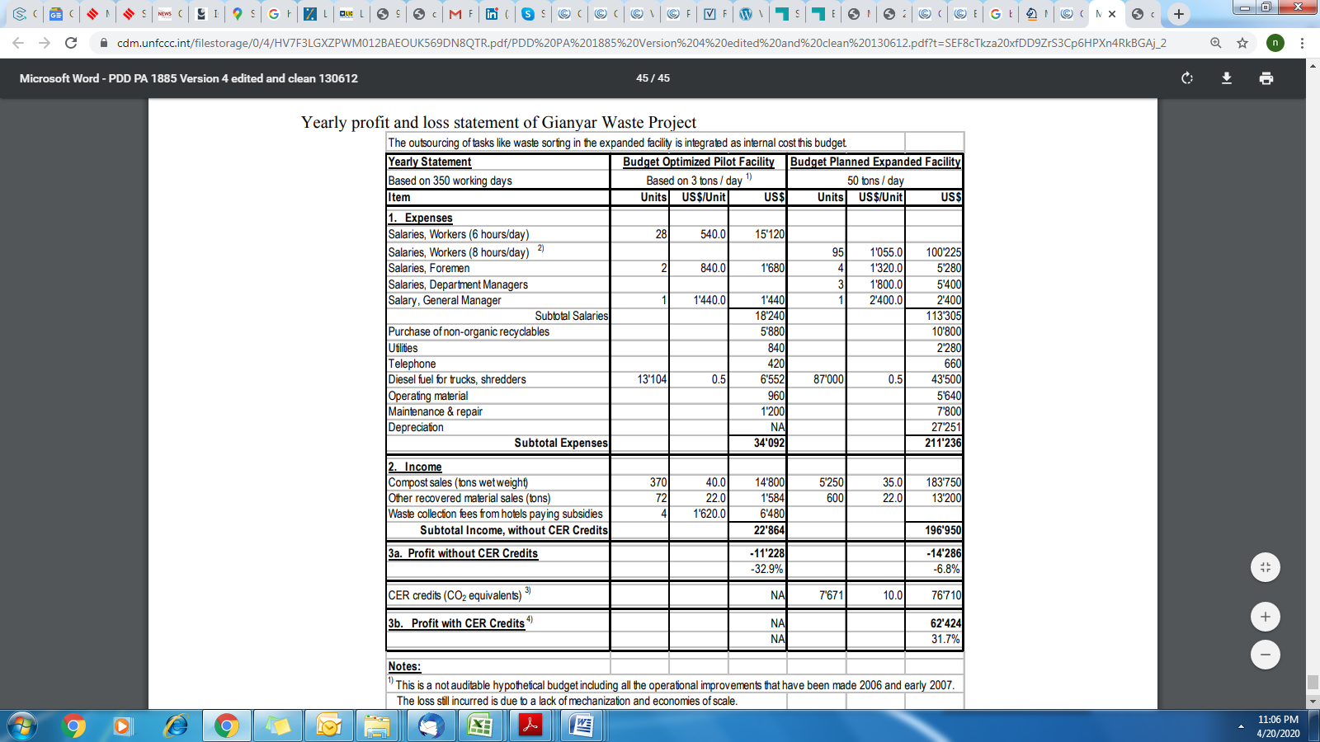

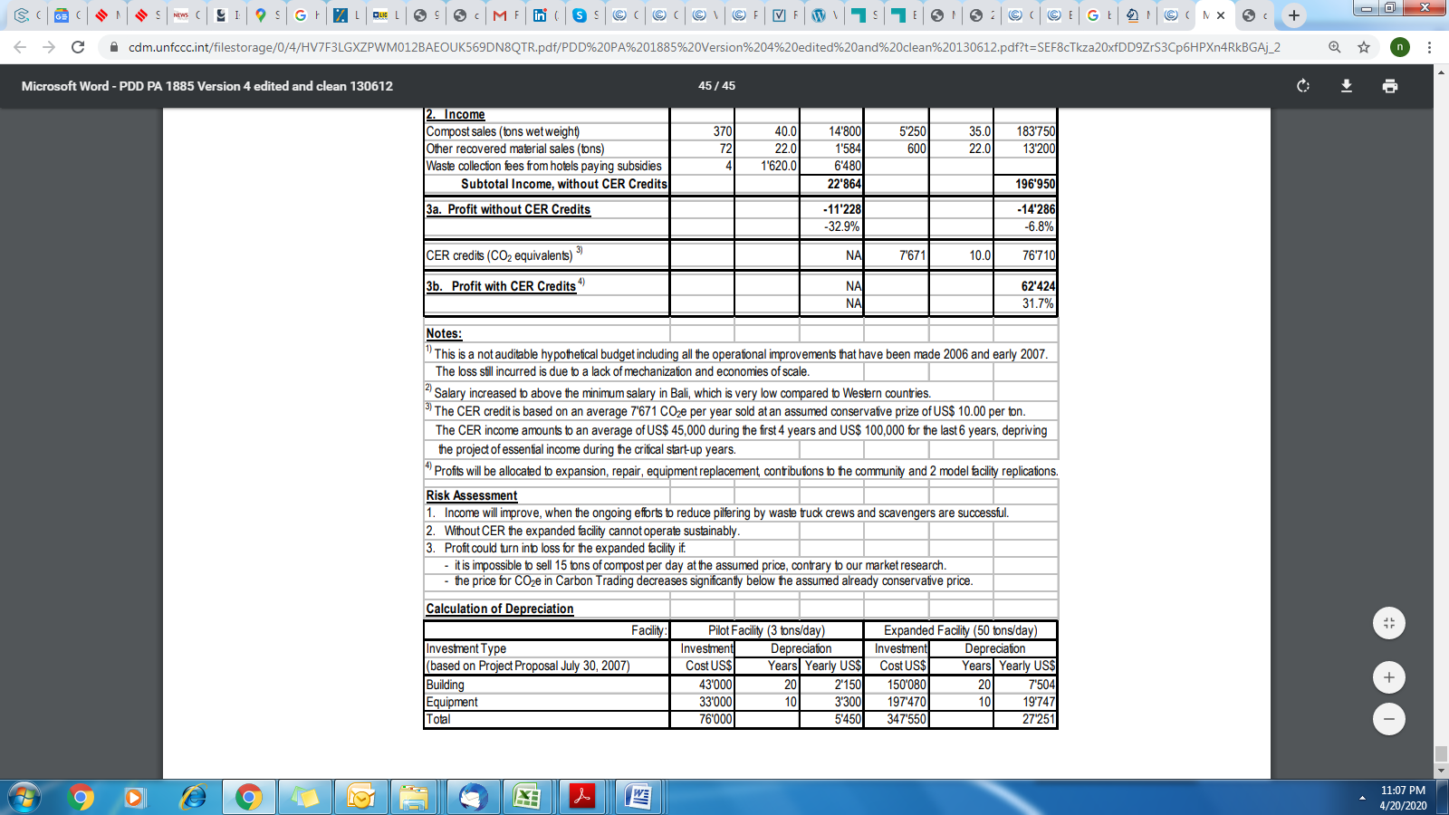

Revision History

|  |  |  |
| --- | --- | --- |
| Version | Date | Remarks |
| 1.1 | 24 August 2017 | Updated to include section A.8 on ‘gender sensitive’ requirements |
| 1 | 10 July 2017 | Initial adoption |
| 2.0 | 28 April 2020 | Project Design Document By GoldStandard and SustainCert |
|  |  |  |
|  |  |  |

1. <https://www.un.org/sustainabledevelopment/sustainable-development-goals/> [↑](#footnote-ref-1)
2. Section 1.2, <https://globalgoals.goldstandard.org/200-gs4gg-community-services-activity-requirements/> [↑](#footnote-ref-2)
3. 4 <https://www.ncbi.nlm.nih.gov/pubmed/7330367> [↑](#footnote-ref-3)
4. <https://www.un.org/womenwatch/daw/Review/responses/INDONESIA-English.pdf> [↑](#footnote-ref-4)
5. *2016 Human Development Report (HDR),* United Nations Development Program [↑](#footnote-ref-5)
6. https://cdm.unfccc.int/methodologies/DB/NZ83KB7YHBIA7HL2U1PCNAOCHPUQYX [↑](#footnote-ref-6)
7. <https://link.springer.com/article/10.1007/s10163-020-00989-5> [↑](#footnote-ref-7)
8. <https://www.eawag.ch/fileadmin/Domain1/Abteilungen/sandec/publikationen/SWM/Assessment_Approaches/gianyar.pdf> (Section 4.3, Economic aspects) [↑](#footnote-ref-8)
9. <https://sustainabledevelopment.un.org/memberstates/indonesia> [↑](#footnote-ref-9)
10. <http://www.mongabay.co.id/2016/08/21/degradasi-lahan-pertanian-ancam-swasembada-pangan-nasional/> [↑](#footnote-ref-10)
11. <https://treaties.un.org/Pages/ViewDetails.aspx?src=IND&mtdsg_no=XXVII-7-d&chapter=27&clang=_en> [↑](#footnote-ref-12)